

Task Title: Using a Provincial Park Map

# OALCF Cover Sheet – Practitioner Copy

**Learner Name: __________________________________________**

**Date Started: ___________________________________________**

**Date Completed: _________________________________________**

|  |  |  |
| --- | --- | --- |
| **Goal Path:** | Employment | Apprenticeship |
| Secondary School | Post Secondary | Independence |

**Successful Completion:**  Yes No

**Task Description:** The learner will look at a park map and identify locations and routes.

**Main Competency/Task Group/Level Indicator:**

* Find and Use Information/Interpret documents/A2.2

**Materials Required:**

* Pen/pencil/highlighter and paper

# Learner Information

When visiting a park, many people will use a map and legend to find their way around.

Scan the “Park Map” and “Map Icons Legend”.

**Park Map**

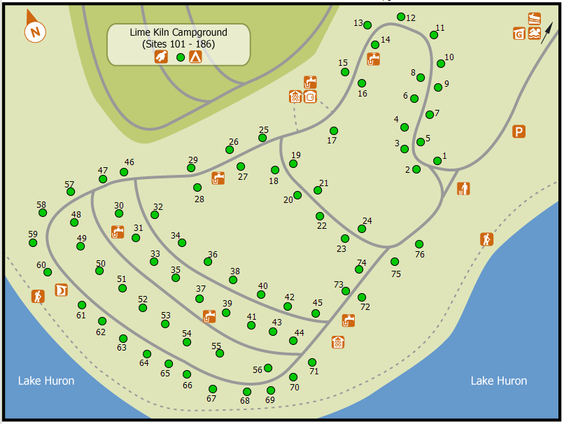

| **Map Icons Legend** | | | | | |
| --- | --- | --- | --- | --- | --- |
| **Symbol** | **Meaning** | **Symbol** | **Meaning** | **Symbol** | **Meaning** |
| Electrical Campsite | Electrical Campsite | **Non - Electrical Campsite** | Non - Electrical Camping | **Parking Icon** | Parking |
| Group Camping Icon | Group Camping | **Information** | Information | **Visitor Center Icon** | Visitor Center |
| Gatehouse Icon | Gatehouse | **Park Office** | Park Office | **Park Store** | Park Store |
| Garbage Icon | Garbage | **Recycling Icon** | Recycling | **Trailer Dumping Icon** | Trailer Dumping |
| Trailer Filling | Trailer Filling | **Water Tap** | Water Tap | **Pit/Vault Toilet** | Pit/Vault Toilet |
| Comfort Station Icon | Comfort Station | **Comfort Station With Showers Icon** | Comfort Station with Showers | **Laundry Facilities Icon** | Laundry Facilities |
| Radio Free | Radio Free | **Wheel Chair Accessible** | Wheel Chair Accessible | **Boat Launch Icon** | Boat Launch |
| Day Use Area Icon | Day Use Area | **Picnic Shelter Icon** | Picnic Shelter | **Water/Canoe Route** | Water/Canoe Route |
| Park Property | Park Property | **Private Property** | Private Property | **Portage Routes** | Portage Routes |
| Beach | Beach | **Amphitheater Icon** | Amphitheater | **Fishing / Cleaning Station Icon** | Fishing / Cleaning Station |
| Campfire Circle Icon | Campfire Circle | **Swimming Icon** | Swimming | **Playground Icon** | Playground |
| Hiking | Hiking | **Canoeing** | Canoeing | **Canoe Launch** | Canoe Launch |
| Canoe Rack | Canoe Rack | Horseshoes Icon | Horseshoes | Ball Diamond / Play Field Icon | Ball Diamond / Play Field |
| Pay Phone Icon | Pay Phone | Marsh Icon | Marsh | Volleyball / Basketball Court Icon | Volleyball / Basketball Court |
| Biking | Biking | Cemetery | Cemetery | Change Room | Change Room |
| Church | Church | Emergency Phone | Emergency Phone | Grocery | Grocery |
| Firewood | Firewood | First Aid | First Aid | Picnic Area | Picnic Area |
| Group Picnic Area | Group Picnic Area | Horse Back Riding | Horse Back Riding | Lookout | Lookout |
| Organic Waste | Organic Waste | Exercise Area | Exercise Area | Pet Free | Pet Free |
| Portage | Portage | Warming Hut | Warming Hut | Self Serve Fee Station | Self-Serve Fee Station |
| Walkin Campsite | Walk-in Campsite |  |  |  |  |

# Work Sheet

**Task 1: On the map, circle the showers bathroom closest to site #75.**

Answer: No written response required here.

Task completed: Yes:

**Task 2: Circle the water tap closest to site #75.**

Answer: No written response required here.

Task completed: Yes:

**Task 3: Circle the designated parking area.**

Answer: No written response required here.

Task completed: Yes:

**Task 4: Draw the road route you would take from site #75 to the designated swimming area.**

Answer: No written response required here.

Task completed: Yes:

Answers





Task 4

Task 3



Task 2

Task 1

# Performance Descriptors

| Levels | Performance Descriptors | Needs Work | Completes task with support from practitioner | Completes task independently |
| --- | --- | --- | --- | --- |
| A2.2 | performs limited searches using one or two search criteria |  |  |  |
|  | extracts information from tables and forms |  |  |  |
|  | locates information in simple graphs and maps |  |  |  |
|  | uses layout to locate information |  |  |  |
|  | makes connections between parts of documents |  |  |  |
|  | makes low-level inferences |  |  |  |
|  | begins to identify sources and evaluate information |  |  |  |

This task: Was successfully completed Needs to be tried again

Learner Comments:

Instructor (print): Learner (print):

**__________________ _________________**