

Task Title: Using Measuring Tapes

# OALCF Cover Sheet – Practitioner Copy

**Learner Name: __________________________________________**

**Date Started: ___________________________________________**

**Date Completed: _________________________________________**

|  |  |  |
| --- | --- | --- |
| **Goal Path:** | Employment | Apprenticeship |
| Secondary School | Post Secondary | Independence |

**Successful Completion:**  Yes No

**Task Description:** The learner marks metric and Imperial measurements on a tape measure.

**Main Competency/Task Group/Level Indicator:**

* Understand and Use Numbers/Use measures/C3.1

**Materials Required:**

* Pen/pencil and paper and/or digital device

# Learner Information

Construction workers and other tradespeople measure materials using either metric or Imperial measures on measuring tapes.

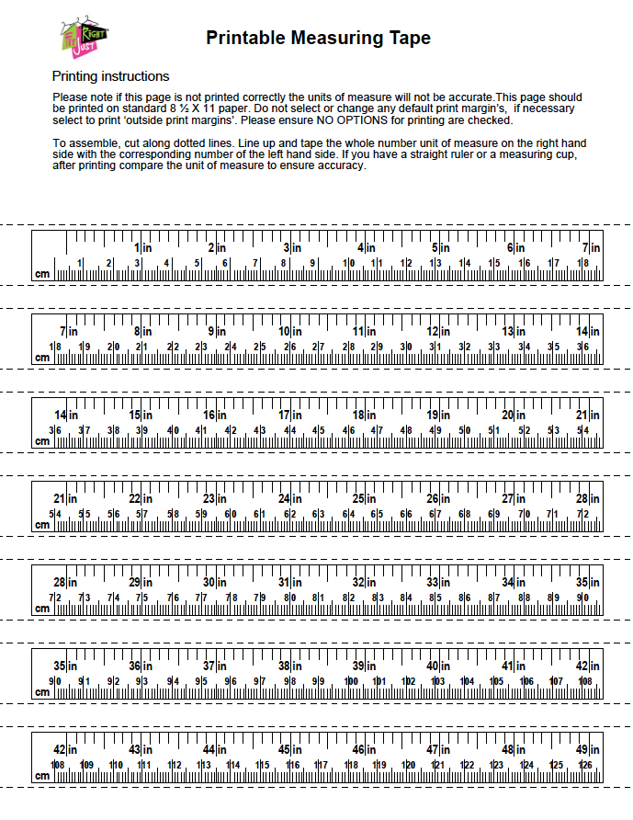**Tape Measure**

# Work Sheet

**Task 1: On the measuring tape, mark and label:**

**Task 1a) 1 1/4 inches**

**Task 1b) 11 1/8 inches**

**Task 1c) 14 7/8 inches**

**Task 1d) 28 1/2 inches**

Answer: No written response required here.

Task completed: Yes:

**Task 2: On the measuring tape, mark and label:**

**Task 2a) 1.5 cm**

**Task 2b) 26.2 cm**

**Task 2c) 60.7 cm**

**Task 2d) 140.0 cm**

Answer: No written response required here.

Task completed: Yes:

# Answers



1a) 1 1/4 ”

2a) 1.5 cm

1b) 11 1/8 ”

1c) 14 7/8 ”

2b) 26.2 cm

1d) 28 1/2 ”

2c) 60.7 cm

2d) 104 cm

# Performance Descriptors

| Levels | Performance Descriptors | Needs Work | Completes task with support from practitioner | Completes task independently |
| --- | --- | --- | --- | --- |
| C3.1 | measures distance, length, width, height, weight, liquid volume, angles and temperature |  |  |  |
|  | uses common measuring tools, such as rulers, scales and thermometers |  |  |  |
|  | chooses appropriate units (e.g. metres, inches) and non-standard units (e.g. paces, cupfuls, scoops) |  |  |  |
|  | interprets and represents measures using whole numbers, decimals and simple, common fractions (e.g. ½, ¼) |  |  |  |
|  | interprets and represents measures using symbols and abbreviations (e.g. inches as “, centimetres as cm, pounds as lbs, kilograms as kilos or kg) |  |  |  |

This task: Was successfully completed Needs to be tried again

Learner Comments:

Instructor (print): Learner (print):

**__________________ _________________**