

Task Title: Using a Monthly Calendar

OALCF Cover Sheet – Practitioner Copy

Learner Name: __________________________________________
Date Started: ___________________________________________
Date Completed: _________________________________________

Goal Path: | Employment | Apprenticeship
Secondary School | Post Secondary | Independence
Successful Completion: Yes No

Task Description: The learner will write appointments and activities on a monthly calendar.
Main Competency/Task Group/Level Indicator:
- Communicate Ideas and Information/Complete and create documents/B3.1a
- Understand and Use Numbers/Use measures/C3.1
Materials Required:
- Pen/pencil and paper and/or digital device

Learner Information
Many people record appointments and activities on a monthly calendar.
Scan the “September 2025” calendar.

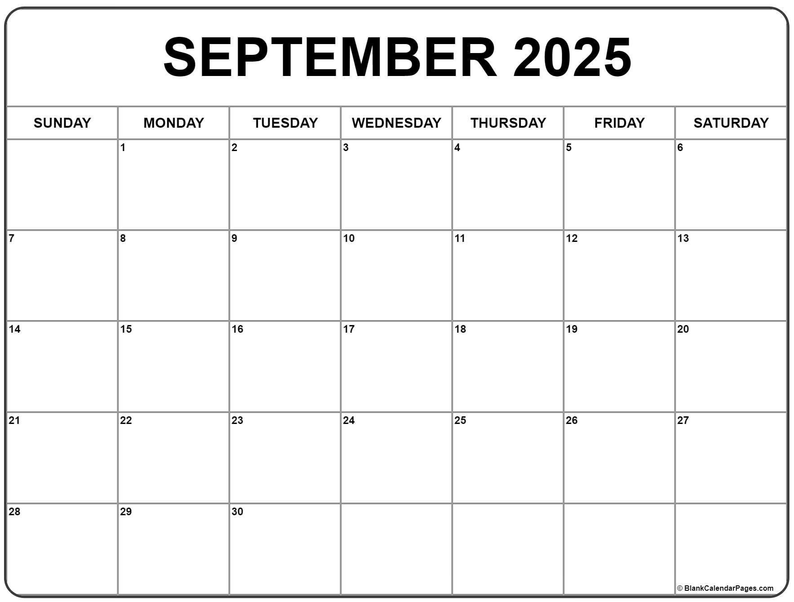

Work Sheet
Task 1: You have a doctor’s appointment on Tuesday, September 16th at 11:30am. Write this appointment in the calendar.
Answer: No written response required here.

Task completed: Yes:

Task 2: Baseball practice is every Saturday morning at 10:30am. Write this in the calendar.
Answer: No written response required here.

Task completed: Yes:

Task 3: You borrowed library books on September 12th. They are due two weeks later. Write the due date in the calendar.
Answer: No written response required here.

Task completed: Yes:

Task 4: You are working from 1pm to 6pm every Monday except the last Monday of the month. Write these shifts in the calendar.
Answer: No written response required here.

Task completed: Yes:

Answers

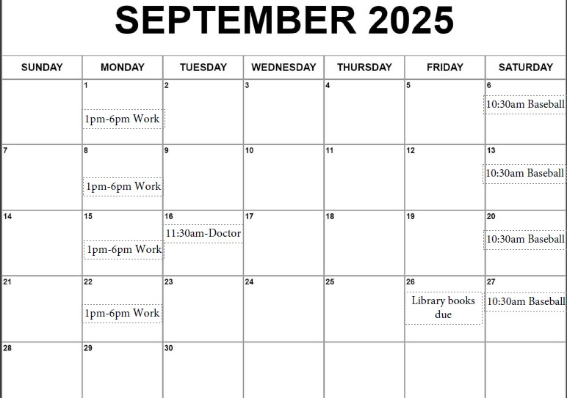

Performance Descriptors
Levels | Performance Descriptors | Needs Work | Completes task with support from practitioner | Completes task independently
B3.1a | makes a direct match between what is requested and what is entered
 | makes entries using familiar vocabulary
C2.1 | recognizes values in number and word format
 | understands chronological order
 | understands and uses common date formats
 | represents dates and times using standard conventions

This task: Was successfully completed Needs to be tried again
Learner Comments:

Instructor (print): Learner (print):
__________________ _________________

