

Task Title: Your Banking Options – Ways to Bank

OALCF Cover Sheet – Practitioner Copy

Learner Name: __________________________________________
Date Started: ___________________________________________
Date Completed: _________________________________________

Goal Path: | Employment | Apprenticeship
Secondary School | Post Secondary | Independence
Successful Completion: Yes No

Task Description: The learner will read an overview of banking options at Libro Credit Union to learn about services available.
Main Competency/Task Group/Level Indicator:
- Find and Use Information/Read continuous text/A1.2
- Understand and Use Numbers/Manage money/C2.1
Materials Required:
- Pen/pencil and paper and/or digital device

Learner Information
Credit unions and banks offer different types of services to customers.

Read “Ways to Bank”.

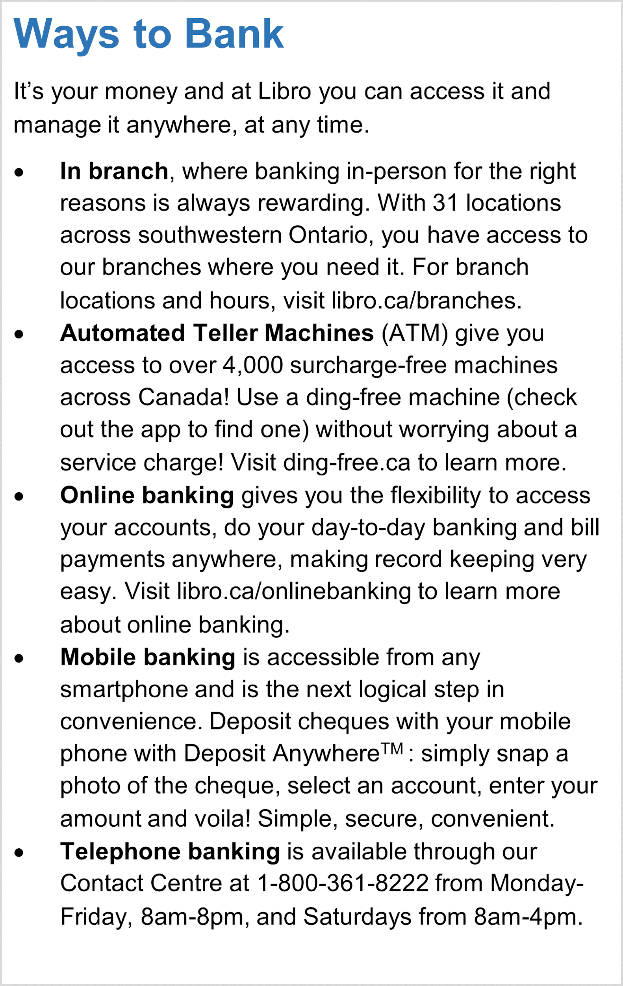

Work Sheet
Task 1: How many Automated Teller Machines does someone have access to across Canada as a customer of Libro?
Answer:

______________________________________________________
Task 2: List three things you can do with online banking.
Answer:

______________________________________________________
Task 3: Explain how you can deposit a cheque using the mobile phone app Deposit Anywhere.
Answer:

______________________________________________________
Task 4: On a weekday, how many hours is the telephone banking contact centre available to customers?
Answer:

______________________________________________________

Answers
Task 1: How many Automated Teller Machines does someone have access to across Canada as a customer of Libro?
Answer: Over 4,000

Task 2: List three things you can do with online banking.
Answer:
- Day-to-day banking
- Bill payments
- Flexible access to your accounts

Task 3: Explain how you can deposit a cheque using the mobile phone app Deposit Anywhere.
Answer: snap a photo of the cheque, select an account, and enter the amount.

Task 4: On a weekday, how many hours is the telephone banking contact centre available to customers?
Answer: Monday to Friday from 8am – 8pm = 12 hours per day during the week.

Performance Descriptors
Levels | Performance Descriptors | Needs Work | Completes task with support from practitioner | Completes task independently
A1.2 | scans text to locate information
 | locates multiple pieces of information in simple texts
 | reads more complex texts to locate a single piece o information
 | obtains information from detailed reading
C2.1 | adds, subtracts, multiplies, and divides whole numbers and decimals
 | understands chronological order
 | identifies and performs required operation

This task: Was successfully completed Needs to be tried again

Learner Comments:

Instructor (print): Learner (print):
__________________ _________________

