

Task Title: Read Tools Flyer

OALCF Cover Sheet – Practitioner Copy

Learner Name:
Date Started:
Date Completed:
Goal Path: | Employment | Apprenticeship
Secondary School | Post Secondary | Independence
Successful Completion: Yes No

Task Description:
Read a sales flyer to find information about tools and calculate cost savings.

Main Competency/Task Group/Level Indicator:
- Find and Use Information/Interpret documents/A2.2
- Understand and Use Numbers/Manage money/C1.1

Materials Required:
- Pen & paper and/or digital device
- Calculator, optional

Learner Information
Store sales flyers contain information about tools that are needed by trades workers. Scan the Millbank Hardware Spring Flyer.

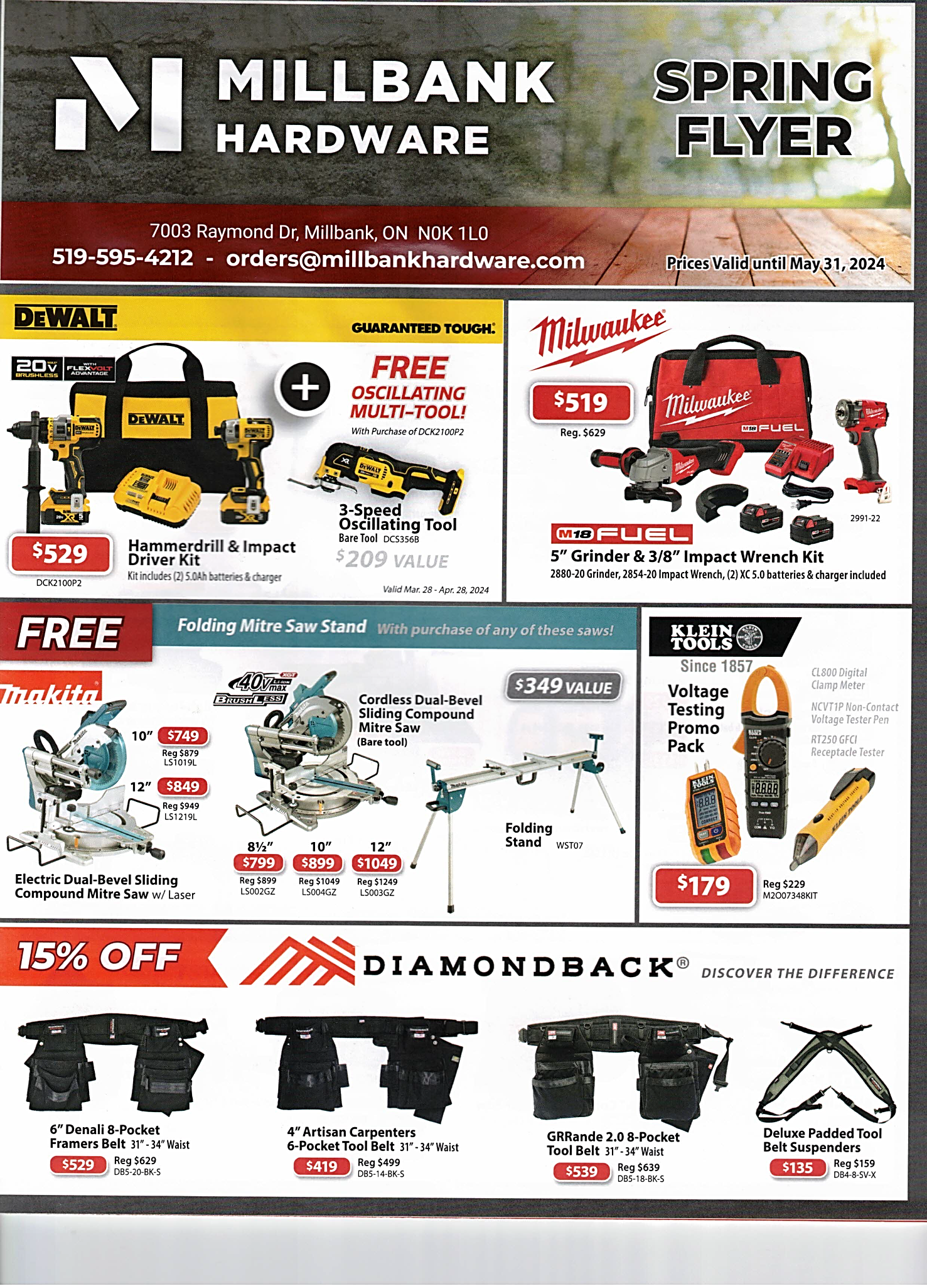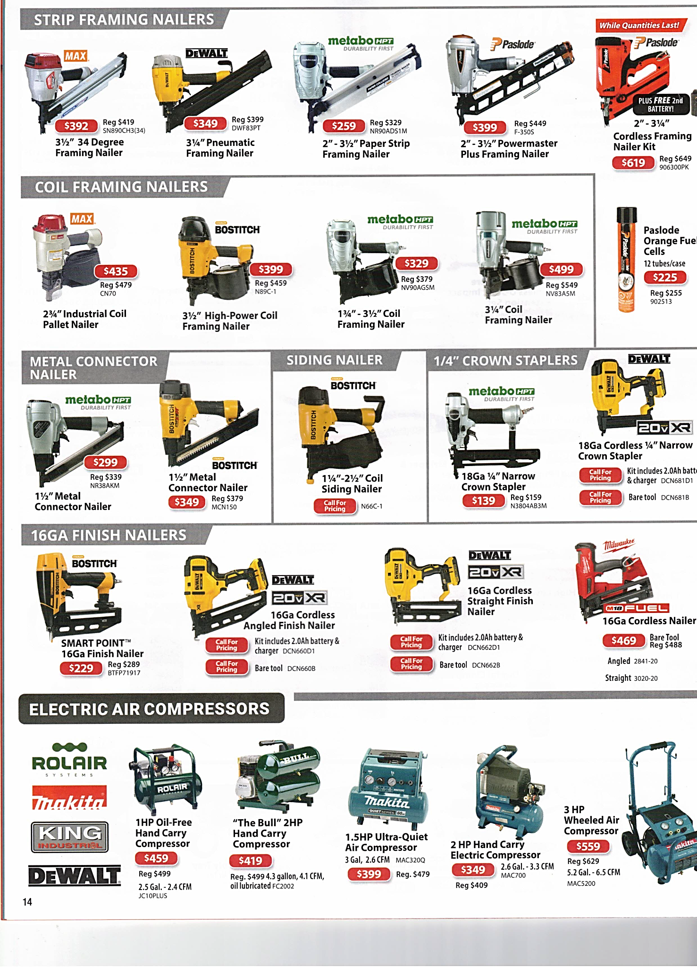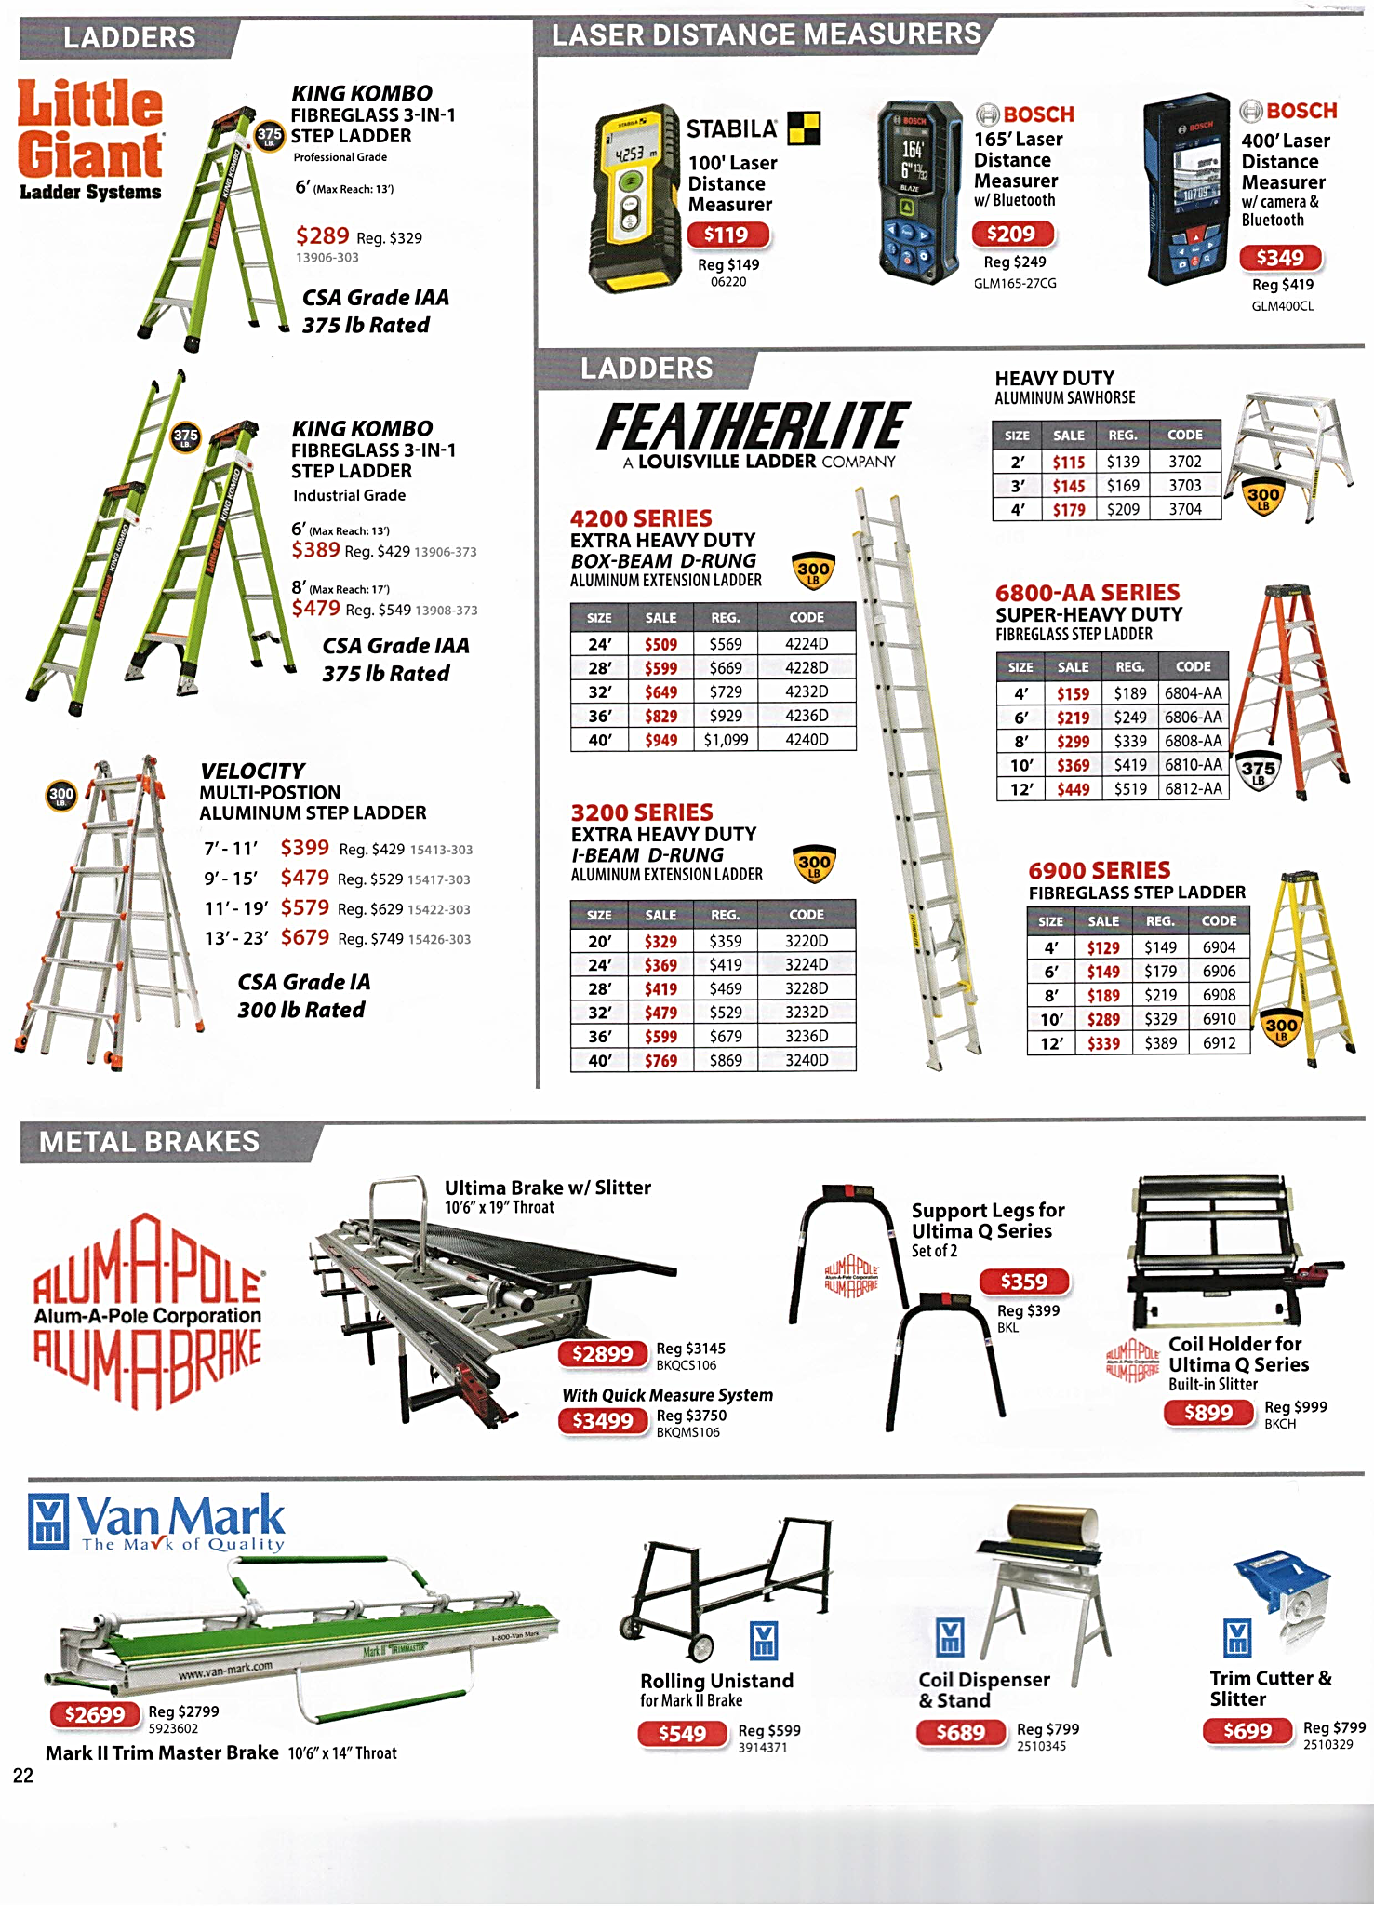

Work Sheet
Task 1: What is the address for Millbank Hardware including postal code?
Answer:

Task 2: What is the email address you would use to order items online from Millbank Hardware?
Answer:

Task 3: List the 2 product codes of the ladders that can reach 40 feet.
Answer:

Task 4: List the items that are included in the Milwaukee Grinder and Wrench kit.
Answer:

Task 5: On sale, calculate how much less money the 2 HP Hand Carry Electric Air Compressor costs than the 3 HP Wheeled Air Compressor.
Answer:

Task 6: Calculate the cost savings for the sale on the voltage testing promo pack.
Answer:

Answers
Task 1: What is the address for Millbank Hardware?
Answer: 7003 Raymond Dr., Millbank, ON N0K 1L0

Task 2: What is the email address you would use to order items online from Millbank Hardware?
Answer: orders@millbankhardware.com

Task 3: List the 2 product codes of the ladders that can reach 40 feet.
Answer: 3240D, 4240D

Task 4: List the items that are included in the Milwaukee Grinder and Wrench kit.
Answer: Grinder, Impact Wrench, 2 batteries, charger

Task 5: On sale, calculate how much less money the 2 HP Hand Carry Electric Air Compressor costs than the 3 HP Wheeled Air Compressor.
Answer: $210 (Sale price: $559 - $349 = $210)

Task 6: Calculate the cost savings for the sale on the voltage testing promo pack.
Answer: $229 - $179 = $50

Performance Descriptors
Levels | Performance Descriptors | Needs Work | Completes task with support from practitioner | Completes task independently
A2.2 | Uses layout to locate information
A2.2 | Extracts information from tables and forms.
C1.1 | Calculates using numbers expressed as whole numbers.
C1.1 | Represents costs and rates using monetary symbols, decimals, and percentages

This task: Was successfully completed Needs to be tried again

Learner Comments:

Instructor (print): Learner (print):

