OALCF Task Cover Sheet
Task Title: Read a Bulletin Board Notice
Learner Name:

Date Started: Date Completed:

Successful Completion: Yes___ No___
Goal Path: Employment √ Apprenticeship___ Secondary School___ Post Secondary___ Independence √
Task Description:
In this task set a learner is asked to read a bulletin board notice and identify various key points. The learner will then write their own notice for an item they have lost.

Competency:  A: Find and Use Information  B: Communicate Ideas and Information | Task Group(s):  A1: Read continuous text  A2: Interpret documents  B2: Write continuous text
Level Indicators:
A1.1: Read brief texts to locate specific details
A1.2: Read texts to locate and connect ideas and information
A2.1: Interpret very simple documents to locate specific details
B2.1: Write brief texts to convey simple ideas and factual information
Performance Descriptors: see chart on last page
Materials Required:
- Attached notice
- Question sheet
- Paper
- Pen/pencil
- This activity could easily be moved into “Use Digital Technology” to create the notice
- This activity could also involve B3.1b by having the learner create a notice using a template
- Skill building activities could include writing simple journals and reading short paragraphs for simple comprehension and reading between the lines

Task Title: Read a Bulletin Board Notice

Bulletin Board Notice
Task 1: Find the following information on the bulletin:
- What has been lost? ___________________________________________________________

- Where was it lost? ___________________________________________________________

- When was it lost? ____________________________________________________________

- What was in the handbag? ______________________________________________________

- Who will you call if you find it? ________________________________________________

- What will happen when you return the bag to its owner?

______________________________________________________________________________

Task 2: How would you feel if you lost something that was special to you?

_______________________________________________________________________________

Task 3: Imagine you have lost an item. Write a short note you can pin on a bulletin board in your apartment building or at a local store. You can use words from the ad you read.

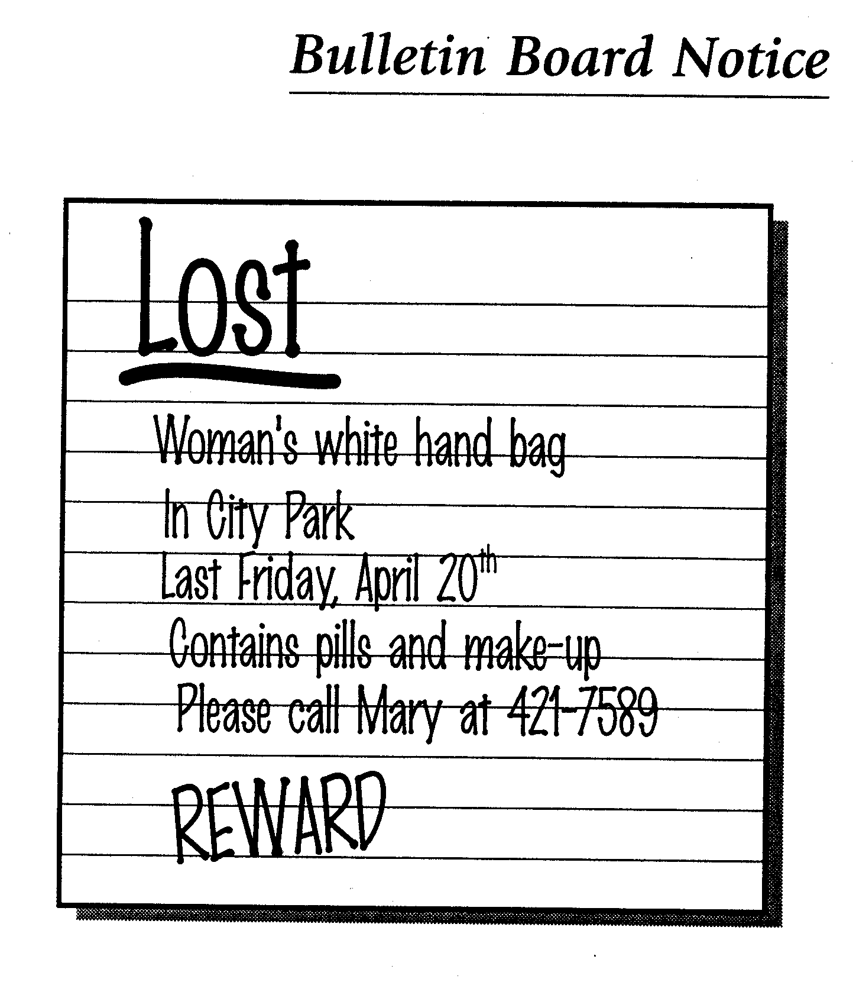

Task Title: Read a Bulletin Board Notice
Performance Descriptors |  | Needs Work | Completes task with support from practitioner | Completes task independently
A1.1 | - reads short texts to locate a single piece of information
A1.2 | - makes low-level inferences
A2.1 | - scans to locate specific details
B2.1 | - writes simple texts to request, remind, or inform
 | - conveys simple ideas and factual information

This task: was successfully completed___ needs to be tried again___

Learner Comments

____________________________ _________________________

Instructor (print) Learner Signature

