
OALCF Task Cover Sheet
Task Title: Read a short story for pleasure
Learner Name:

Date Started: Date Completed:

Successful Completion: Yes___ No___
Goal Path: Employment __ Apprenticeship___ Secondary School ✓ Post Secondary___ Independence ___
Task Description:
Read the short story silently and then aloud. Answer the comprehension questions verbally, or in writing if preparing for secondary school credits.

Competency:  - Find and use information  - Communicate ideas and information  E. Manage Learning | Task Group(s):  A1: Read continuous text  B1: Interact with others OR  B2: Write continuous text  E1: Manage Learning
Level Indicators:
A1.1: Read brief texts to locate specific details
B1.1: Participate in brief interactions to exchange information with one other person
OR
B2.1: Write brief texts to convey simple ideas and factual information
E.1: Set short-term goals, begin to use limited learning strategies and begin to monitor own learning

Performance Descriptors: see chart on last page
Materials Required:
- Short story and questions
- Dictionary

Task Title: Read a short story for pleasure
Practitioner Instructions:
- Review the learner’s instructions with the student.
- Go over the checklist with the learner so that they are aware of the skills to be demonstrated.
- Have the learner select a story which interests him/her, then read the story silently. Ask them if there are any words they don’t know. Encourage them to decode the words independently, but help if necessary, especially with unusual names. If the learner does not know the meaning of any word, ask them to look it up in a dictionary.
- Ask the learner to read the story aloud.
- Ask the learner to retell the story in their own words.
- Have the learner answer the comprehension questions. You may write their answers if they cannot write them independently.
- When the learner has completed the activity, complete the evaluation together, enter the date completed, and note whether it was successful or needs to be tried again.

Practitioner Information:
Help Allowed: The practitioner may help the learner decode one or two words if necessary.
Since this is a reading activity, the practitioner may write down the learner’s answers if they cannot write them independently.
Evaluation: Listen to them read the short story and assess fluency, expression and attention to the periods. They should be able to answer most of the comprehension questions.

Adaptation: Any short story at level 1 may be used. (Two examples are given here.)
Answers to Multiple Choice:
- b
- c
- a
- c
- a
- a

Task Title: Read a short story for pleasure
Learner Information and Instructions:

Task 1: Select the short story which interests you the most.

Task 2: Read the story silently. If there are any words that you don’t know, try to figure them out. If you need help with one or two words, your instructor may help you.

Task 3: Answer comprehension questions on the short story that you read. You may choose to write your own answers, or you can tell your instructor your answers and they will write them down for you.

My Walk
One day I went for a walk. I went down a long path until I came to a log cabin. I started to look around to see if anyone was home.
Then I heard a bang. I went to see what it was, but I did not see anything. I looked and looked. But I still did not see anything.
Then I came back outside. There stood a big black bear. I went back inside and closed the door.

Elephant Set Free after Years in Chains.
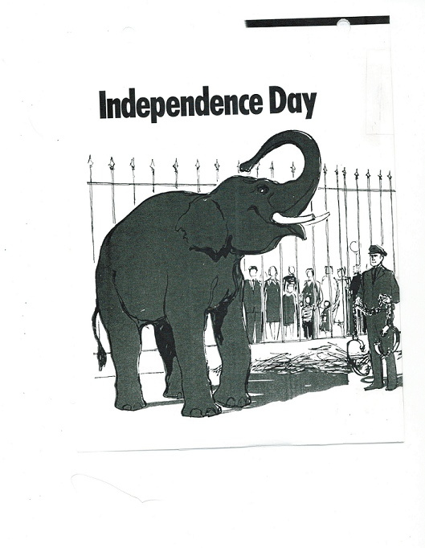
It was a hot 4th of July. Ziggy, a very big elephant, lifted his trunk into the air. He gave a very loud roar. It could be heard all over the zoo. Ziggy was glad it was Independence Day. Heavy chains had just been taken off his legs. He was free, at last, to move around in his cage.
Many years before, Ziggy had been a man’s pet. The man’s name was Ziegfeld. This man put on big musical shows. All kinds of animals were in these shows. Ziggy was in one of these shows. When the man died Ziggy was put in a zoo.
After ten years in the zoo, Ziggy hurt his keeper. This cost him his freedom. Chains were put around his legs. For thirty-two years Ziggy could not move about freely. He was so happy. Now he was free to move about his cage.
Questions for “My Walk”
- What did the author find on the path?
- Was the path long or short?
- What did the author hear?
- What did he find outside the door?
- What did he do?
- What do you think happened next?
- How would you feel if this happened to you?

Questions for “Elephant Set Free after years in Chains”
Select the answer that best completes each sentence:
- Ziggy is the name of  - a man who put on musical shows.  - an elephant.  - a Chicago zoo. | - At one time, Ziggy belonged to  - the Ringling Brothers.  - The Bronx Zoo.  - Florenz Ziegfeld.
- Ziggy was put in a zoo after  - his owner died.  - he attacked his keeper.  - he attacked his owner. | - Ziggy was put in chains because  - he bit another elephant.  - he tried to run away.  - he attacked his keeper.
- Ziggy was kept in chains for  - thirty-two years.  - ten years.  - thirty-two weeks. | - Another good title for this story would be  - Freedom for Ziggy  - An Important Man in Theatre  - A Chicago Zoo

“What do you think?” questions
- Was it fair to keep Ziggy in chains for 32 years?
- What problems would you have if you had an elephant for a pet?
- Why was this a good day to free Ziggy?
- Do you think the visitors to the zoo were happy to see Ziggy free? Why?

Task Title: Read a short story for pleasure

Learner’s self reflection:

1. I could read most of the words. Yes  No 

2. I understood what I read. Yes  No 

3. I could retell the story in my own words in the Yes  No 
correct order.

4. I found it easy to answer the questions. Yes  No 

5. I answered most of the questions correctly. Yes  No 

6. I enjoyed reading the story. Yes  No 

7. I would like to read another story like this one. Yes  No 

Learner comments:

Task Title: Read a short story for pleasure
Performance Descriptors |  | Needs Work | Completes task with support from practitioner | Completes task independently
A1.1 | - reads short texts to locate a single piece of information
 | - decodes words and makes meaning of sentences in a single text
 | - follows the sequence of events in straightforward chronological texts
 | - identifies the main idea in brief texts
B1.1 | - conveys information on familiar topics
 | - chooses appropriate language in exchanges with clearly defined purposes
 | - participates in short, simple exchanges
 | - speaks or signs clearly in a focused and organized way
B2.1 | - Conveys simple ideas and factual information
 | - conveys simple ideas and factual information
 | - Uses highly familiar vocabulary
E1 | - Begins to monitor progress towards achieving goals
 | - Begins to monitor own learning
This task: was successfully completed___ needs to be tried again___
___________________________________ __________________________________
Learner Signature Instructor

