Task-based Activity Cover Sheet
Task Title: Read a Brief Email
Learner Name:

Date Started: Date Completed:

Successful Completion: Yes___ No___
Goal Path: Employment ✓ Apprenticeship ✓ Secondary School __ Post Secondary __ Independence __
Task Description:
Read a brief email confirming the date and time of a meeting
Competency:  A: Find and Use Information | Task Group(s):  A1: Read continuous text
Level Indicators:
A1.1: Read brief texts to locate specific details
Performance Descriptors: see after answer key or click here.
Links to skill building activities: see the last page or click here
Materials Required:
- Email about the meeting (attached)
- pen/pencil, eraser
ESKARGO:
Reading Strategies:
- Develops sight words related to specific tasks
- Uses phonics and knowledge of word parts to decode words
- Uses knowledge of basic spelling conventions and simple punctuation to gather meaning from sentences
- Uses context cues and personal experience to gather meaning from the text
- Scans simple text to locate a single piece of information
Forms and Conventions:
- Reads sentences up to one paragraph
- Reads text having familiar, everyday content
- Reads text with simple, concrete information in simple, familiar wording
Comprehension:
- Reads signs, symbols and common sight words from everyday life
- Makes meaning of sentences in a single text
Interpretation:
- Locates a single piece of information in short texts

Attitudes:
Practitioner,
We encourage you to talk with the learner about attitudes required to complete this task set. The context of the task has to be considered when identifying attitudes. With your learner, please check one of the following:
□ Attitude is not important □ Attitude is somewhat important □ Attitude is very important

Task Title: Read a Brief Email
Learner Information and Tasks:
Email is a primary method of communication in the workplace. Meetings are often arranged through emails. Read the attached email.

Task 1: Who sent the email?

Task 2: Who was the email sent to?

Task 3: When is the date of the meeting?

Task 4: Where will the meeting be held?

Task 5: When will the meeting start?

Task 6: What colour of book is staff to bring to the meeting?

Task 7: Where will the staff go for lunch?

Email
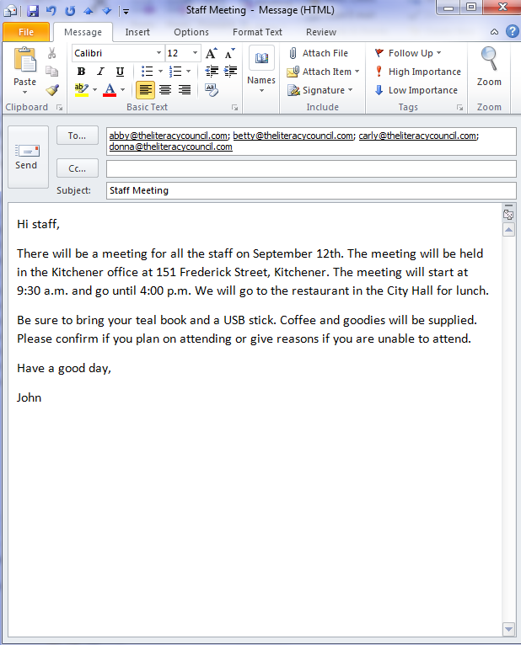

Task Title: Read a Brief Email

Answer Key
Task 1: Who sent the email?
John
Task 2: Who was the email sent to?
Staff (or Abby, Betty, Carly, and Donna or the full email addresses of each)
Task 3: When is the date of the meeting?
September 12th
Task 4: Where will the meeting be held?
The Kitchener office or 151 Frederick Street, Kitchener
Task 5: When will the meeting start?
9:30 a.m.

Task 6: What colour of book is staff to bring to the meeting?
teal
Task 7: Where will the staff go for lunch?
Restaurant [in City Hall] or City Hall

Task Title: Read an Email
Performance Descriptors |  | Needs Work | Completes task with support from practitioner | Completes task independently
A1.1 | - reads short texts to locate a single piece of information
 | - decodes words and makes meaning of sentences in a single text
 | - follows simple, straightforward instructional texts

This task: was successfully completed___ needs to be tried again___

Learner Comments

____________________________ _________________________

Instructor (print) Learner Signature

Skill Building Activities
Links to online resources:
“Practice Reading” Games
http://www.gcflearnfree.org/reading/practicereading/play - Click “launch activity.” Pick something from the top row; the learner will have the option of choosing a variety of categories like office terms, technology, writing, etc. Now pick something “texts” from the bottom row. The learner now has the option to choose “reading comprehension” or “text explorer.” By choosing reading comprehension, the learner is exposed to text and asked a series of questions related to what they have read. By choosing text explorer, the learner can click on the bolded words to hear how the word is pronounced, how the word is used in a sentence, and examples of when/where you might see the bolded word.
Reading and Understanding
http://www.bbc.co.uk/skillswise/quiz/en07unde-l1-quiz - By clicking on this link, the learner is brought to a reading comprehension quiz. There are a series of 10 questions that relate to a small passage that must be read. The questions relate to the passage. At the end of the quiz the learner is given their score. A certificate is available to print.
Practice Reading Texts: Notes, Letters, Memos
http://www.skillplan.ca/measure-up - Select “English”, “Choice of Activities”, “Practice”, “Reading”, and “Notes, Letters, Memos.” The learner will be asked to read simple, straightforward instructions, in notes, letters, and memos. There are worksheets to be printed with questions that relate to the text. After completing the activity, the learner has the option of practising “the same skill” or practising a “different skill.”
LearningHUB Courses Available:
Live Classes (SABA) - “Reading Comprehension”
Essential Skills, Independent Study, Short Courses
Understanding How to Communicate Using Internet and e-Mail

Reading & Writing, Independent Study (Assigned by practitioner after assessment)
Reading Level 1, Assignment: all lessons teach essential reading strategies required to read and understand brief texts (e.g. Finding Main Ideas, Working with Order, Using Context Clues, etc.)
Reading Level 1, Assignment 2: You Have a Message, Getting the Details, What Should I Do, How to Read a Message, Action Plan

*To access LearningHUB courses, learners must register for the LearningHUB e-Channel program by completing the registration form on their website and completing the course selection (page 2 of the registration form): https://www.learninghub.ca/get_registered.aspx
*To Access LearningHUB Course Catalogue:
http://www.learninghub.ca/Files/PDF-files/HUBcoursecatalogue,%20December%2023,%202014%20revision.pdf

