OALCF Task Cover Sheet
Task Title: Read a Recipe and create a grocery list

Learner Name:

Date Started: Date Completed:

Successful Completion: Yes___ No___
Goal Path: Employment___ Apprenticeship___ Secondary School___ Post Secondary___ Independence √

Task Description:
The learner is asked to read and record the ingredients (and amount of each ingredient). Then they are asked to create a grocery list from the ingredient list.

Competency:  A: Find and Use Information  B: Communicate Ideas and Information | Task Group(s):  A1: Interpret documents  B1: Interact with others  B2: Write continuous text  B3: Complete and create documents
Level Indicators:
A1.1: Read brief texts to locate specific details.
B 1.1: Participate in brief interactions to exchange information with one other person.
B 2.1: Write brief texts to convey simple ideas and factual information
B 3.1: Create very simple documents to display and organize a limited amount of information.
Performance Descriptors: see chart on last page
Materials Required:
- Ingredient list
- Task sheet
- Matching Sheet (skill building activity)
- Pen/pencil
- Paper

Learner Information and Instructions

Task Title: Read a Recipe and Create a Grocery List

Task: Read each ingredient from the “Vegetable Light Latkes” ingredient list. Now record the amount needed for each ingredient in the list provided (Question3.). Next, copy the ingredient and amount on the paper provided. From this list, create a grocery list of ingredients to buy.

Instructions: Four tasks are described below. A fifth (optional) task is described on another page and can be done as a skill building activity.

Task 1:

Scan the “Vegetable Light Latkes” document. What is the purpose of this document?

Task 2:

What are the ingredients required to make “Vegetable Light Latkes?”

(Instructor: Note whether the learner uses illustrations to help read/understand the ingredients.)

Task 3: What amount is required for each ingredient in the “Vegetable Light Latkes” recipe.

Zucchini ____________ carrots ____________

Parsnips ____________ eggs ____________

Oil ____________ flour ____________

Baking powder __________ salt ____________

Onion ____________ pepper ____________

Task 4:

Write a grocery list to make “Vegetable Light Latkes”. Decide how much of each ingredient you will need to buy.

Vegetable Light Latkes

Ingredient List
1 cup zucchini | 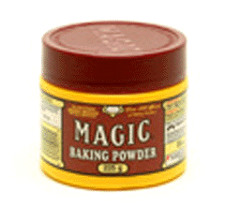  1/3 cup of flour
1 cup carrots | 1/2 teaspoon baking powder
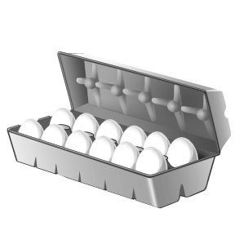  1 cup parsnips | 1/8 teaspoon pepper
3 egg whites | 3/4 teaspoon salt
1 onion | Oil

Task 5: Match the ingredient with the picture:

Onion

Flour

Egg

Pepper

Oil

Zucchini

Salt

Parsnips

Carrots

Baking powder

Task Title: Read a Recipe and Create a Grocery List
Performance Descriptors |  | Needs Work | Completes task with support of practitioner | Completes task independently
A1.1 | - Reads short texts to locate a single piece of information.
B1.1 | - Conveys information on familiar topics.
 | - Participates in short, simple exchanges.
B2.1 | - Writes simple texts to request, remind, or inform.
B3.1 | - Follows conventions to display information in lists, labels, simple forms, signs (e.g. images support the message, text is legible).

This task: was successfully completed___ needs to be tried again___

Learner Comments

____________________________ _________________________

Instructor (print) Learner Signature

