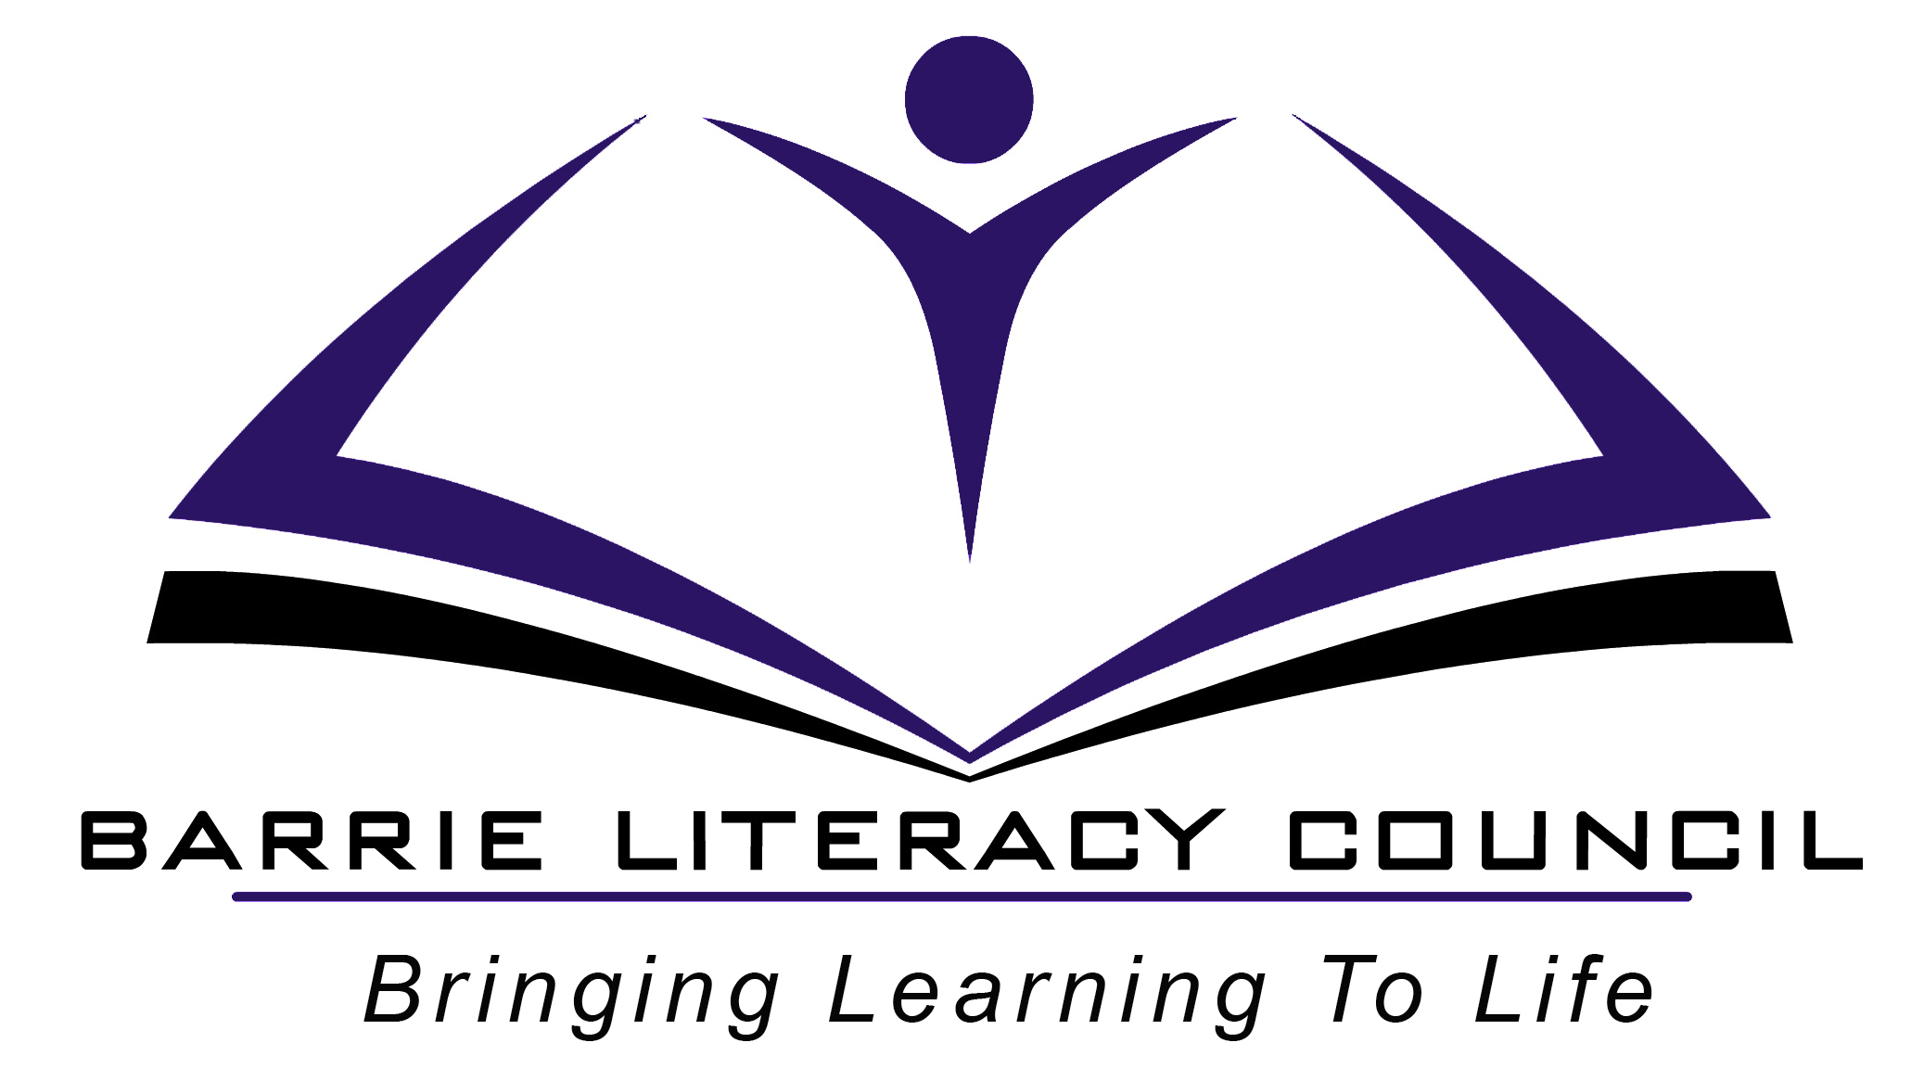
OALCF Task Cover Sheet

Task Title: Read a recipe for spaghetti sauce
Learner Name:

Date Started: Date Completed:

Successful Completion: Yes___ No___
Goal Path: Employment __ Apprenticeship___ Secondary School___ Post Secondary___ Independence ✓
Task Description:
The learner will read a straightforward recipe and then answer questions about the recipe, including showing measurements needed. The learner will describe in their own words how to make spaghetti sauce.

Competency:  - Find and use information  - Communicate ideas and information  - Understand and use numbers | Task Group(s):  A1 Read continuous text  B1 Interact with others  C2 Manage time  C3 Use measures
Level Indicators:
A1.1 Read brief text to locate specific details
B1.1 Participate in brief interactions to exchange information with one other person
C2.1 Measure time and make simple comparisons and calculations
C3.1 Measure and make simple comparisons and calculations

Performance Descriptors: see chart on last page
Materials Required:
Recipe (attached)
Measuring cup and measuring spoons
A pitcher of water and a cup of sugar or salt
Cans of tomatoes and tomato paste
Question sheet

Task Title: Read a recipe for spaghetti sauce
Practitioner Instructions:
- Review the learner’s instructions with them.
- Go over the evaluation checklist with your learner so that they are aware of the skills to be demonstrated.
- When the learner has answered the written questions, ask them to measure out the right amount of each ingredient (except garlic, tomatoes or tomato paste), using water or salt (make sure to explain what are the “wet” ingredients for measuring with water and what are the “dry” ingredients for measuring with salt). Are the cans of tomatoes and tomato paste the right size?
- Ask them to explain to you in correct sequence how they would make spaghetti sauce, following this recipe.
- When the learner has completed the activity, complete the evaluation together, enter the date completed, and note whether it was successful or needs to be tried again.

Practitioner Information:
Help Allowed: The practitioner may read the questions to the learner if needed, and may write down the learner’s answers if needed. They must be able to figure out the recipe on their own.

Adaptation: Any recipe that has brief text may be used.
Rather than tell you how to make the spaghetti sauce, you may decide to have the learner actually make the spaghetti sauce, following the recipe. In that case you will need all the ingredients and an electric fry pan.

Task Title: Read a recipe for spaghetti sauce
Learner Information and Instructions:

Task 1: Read the recipe given to you and answer the tasks below.
Task 2: In front of your instructor measure out the liquid ingredients using water and the dry ingredients using salt (or sugar). Do not measure out the tomatoes or tomato paste.
Task 3: At the end, tell your instructor in your own words how to make spaghetti sauce, using this recipe.
Task 4: What do you do to the onion before you cook it? _______________________________

Task 5: What two things do you cook first? ___________________________________________

Task 6: You have a choice of using two different kinds of oil. What are they?

Task 7: What should you do while the sauce simmers? _________________________________

Task 8: Circle or highlight what you take out of your sauce at the end.

Task 9: How many people will this recipe serve? _____________________________________

Task 10: If you start simmering your sauce at 5:30 p.m., what time should it be ready?

Task Title: Read a recipe for spaghetti sauce

Spaghetti Sauce Recipe

1/3 cup chopped onion
2 cloves garlic, mashed
1/2 tablespoons salad or olive oil
1 can (540 ml) tomatoes
1 can (341ml) tomato paste
2 cups water
1/2 teaspoon sugar
3/4 teaspoon salt
3/4 teaspoon oregano leaves
1/4 teaspoon pepper
1 bay leaf

In a heavy pan, cook onion and garlic in oil until soft. Put tomatoes through blender. Add tomatoes and everything else to onion and garlic. Simmer without a lid for 1 hour. Stir occasionally. Remove bay leaf. Makes about 3 cups, or 2 to 4 servings

Task Title: Read a recipe for spaghetti sauce

Learner’s self reflection:

- I could read the ingredients needed for this recipe. Yes  No 
- I could measure the ingredients accurately. Yes  No 
- I answered at least 6 out of 7 questions correctly. Yes  No 
- I could tell my instructor how to make spaghetti sauce following the steps in order.
Yes  No 
- I now what the word “simmer” means. Yes  No 
- I think I could follow a recipe like this at home. Yes  No 
- I am going to make this recipe at home. Yes  No 

Other comments:

Task Title: Read a recipe for spaghetti sauce– Answer Key

- chop it
- the onion and the garlic
- salad oil or olive oil
- stir sometimes
- bay leaf
- 2 - 4 people
- 6:30 p.m.

Task Title: Read a recipe for spaghetti sauce
Performance Descriptors |  | Needs Work | Completes task with support from practitioner | Completes task independently
A1.1 | - decodes words and makes meaning of sentences in a single text
 | - follow simple, straightforward instructional texts
 | - reads short texts to locate a single piece of information
B1.1 | - Conveys information on a familiar topic
 | - Gives short, straightforward instructions or directions
 | - Speaks or signs clearly in a focused and organized way
C2.1 | - Measures time using common instruments such as clocks
 | - Understands chronological order
 | - Represents dates and times using whole numbers and decimals
C3.1 | - Uses common measuring tools
 | - Interprets measures using whole numbers and simple common fractions
 | - Chooses appropriate units of measurement

This task: was successfully completed___ needs to be tried again___

Learner Comments

____________________________ _________________________

Instructor (print) Learner Signature

