Task-based Activity Cover Sheet
Task Title: Refrigeration and Air Conditioning Product Knowledge
Learner Name:

Date Started: Date Completed:

Successful Completion: Yes___ No___
Goal Path: Employment___ Apprenticeship_✓_ Secondary School Post Secondary Independence___
Task Description:
Understand how to use the internet to search a video-sharing website to locate and use information related to product knowledge.
Competency:  A: Find and Use Information  B: Communicate Ideas and Information  D: Use Digital Technology | Task Group(s):  A3: Extract information from films, broadcasts, and presentations.  B2: Write continuous text  D2: Use digital technology
Level Indicators:
A3.: Tasks in this group are not rated for complexity
B2.1: Write brief texts to convey simple ideas and factual information
D.2: Perform well-defined, multi-step digital tasks
Performance Descriptors: see chart on last page
Materials Required:
- Computer with internet access
- Pencil and paper

Task Title: Refrigeration and Air Conditioning Product Knowledge
Refrigeration and Air Conditioning mechanics use the internet to access training courses and seminars offered by suppliers, employers, and trade schools.
Learner Information and Tasks:
Open a web browser. Go to you tube, and search “Lennox XC25 with Precise Comfort Technology” and select and view the video.
Task 1: Rather than having one or two speeds, explain how the Lennox XC 25 is different from other air conditioners.

Task 2: One or two stage air conditioners may produce temperature swings as they cycle on or off. List two reasons why the Lennox XC25 air conditioner and the XP25 heat pump do not produce temperature swings.

Task 3: The Lennox XC25 has three different levels of moisture removal. List the different levels of moisture removal based on where the customer lives. (A3, B3.1)

Task Title: Refrigeration and Air Conditioning Product Knowledge
Answer Key
- Open the internet
- Use a search engine, such as Google, to search “YouTube”
- 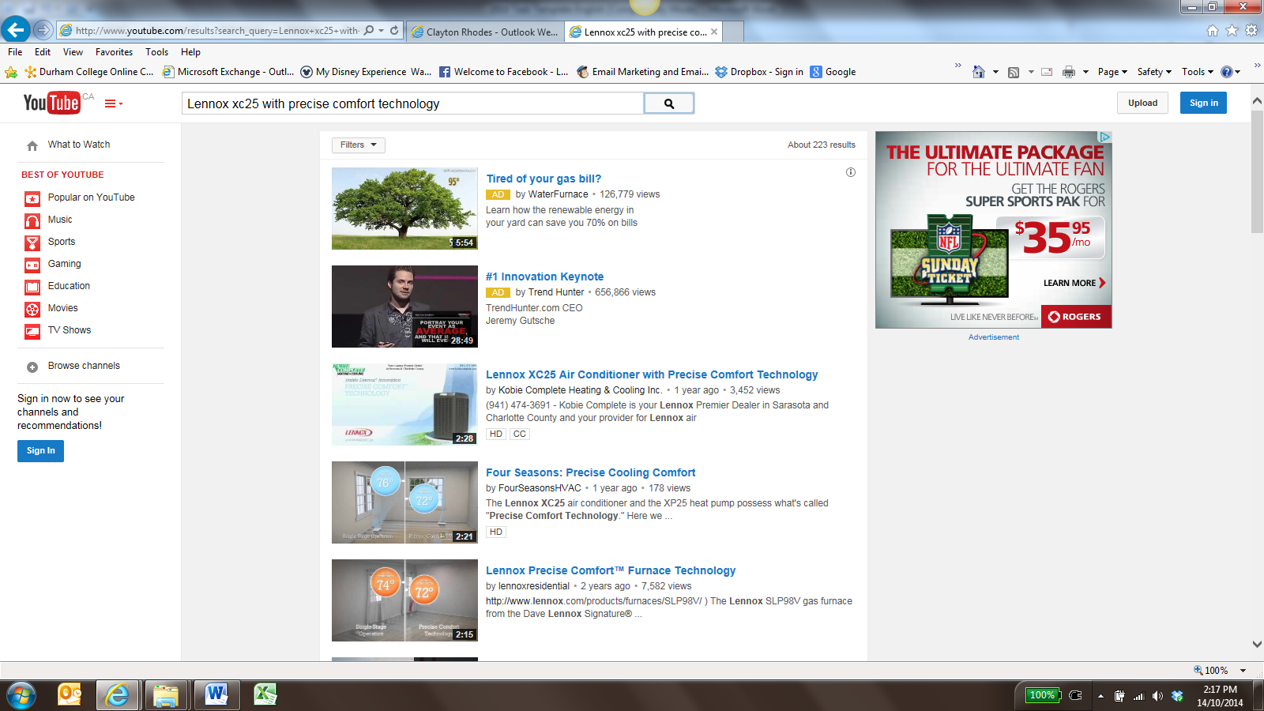
- Image as of October 2014
- YouTube URL: https://www.youtube.com/watch?v=wFxwuf5uDVY
- In the search box, at the top of the screen, type “Lennox XC25 with Precise Comfort Technology”
- View the video with the closest match to the search text
  - Use Closed Captioning (cc) if necessary by clicking on the “cc” image in the bottom right corner of the video screen
Task 1: Rather than one or two stages, the XC25 can adjust compressor speed and output to any level between 35-100 percent in increments of 1 percent.
Task 2: - During warm weather, the XC25 produce a continuous supply of cooled air maintaining the set temperature to within 0.5 (half) degree.
- During cooler weather, the XP25 heat pump (if they do not mention the name of the heat pump this is fine) reverses the flow of heat bringing warmth from outdoor air into the home
Task 3: - normal humidity
- dry regions
- coastal regions

Task Title: Refrigeration and Air Conditioning Product Knowledge
Performance Descriptors |  | Needs Work | Completes task with support from practitioner | Completes task independently
A3 | - Extract information from films, broadcasts and presentations
B2.1 | - writes simple texts to request, remind or inform
 | - conveys simple ideas and factual information
 | - demonstrates a limited understanding of sequence
 | - uses sentence structure, upper and lower case and basic punctuation
 | - uses highly familiar vocabulary
D2.2 | - selects and follows appropriate steps to complete tasks
 | - locates and recognizes functions and commands
 | - makes low-level inferences to interpret icons and text
 | - begins to identify sources and evaluate information
 | - performs simple searches using keywords (e.g. internet, software help menu)

This task: was successfully completed___ needs to be tried again___

Learner Comments

____________________________ _________________________

Instructor (print) Learner Signature

