 Task-based Activity Cover Sheet
Task Title: Rent to Own - Washer and Dryer
Learner Name:

Date Started: Date Completed:

Successful Completion: Yes □ No □
Goal Path: Employment □ Apprenticeship □ Secondary School □ Post-Secondary □ Independence X
Task Description:
Learner will calculate the costs of washers and dryers and compare costs from rent to own and electronic stores.
Competency:  C: Understand and Use Numbers  A: Find and Use Information | Task Group(s):  C1: Manage Money  A2: Interpret documents
Level Indicators:
C1.1: Compare costs and make simple calculations
C1.2: Make low-level inferences to calculate costs and expenses that may include rates such as taxes and discounts
A2.1: Interpret very simple documents to locate specific details

Performance Descriptors: see chart on last page
Materials Required:
- Pencil with eraser and calculator (decision of instructor)

Task Title: Rent to Own - Washer and Dryer
There are businesses that offer payment plans for products. Usually these products include:
- furniture
- televisions
- computers
- appliances
- cell phones
The payment plans can seem really good at first look, but most times you will pay much more for the item. Look at the two ads for Maytag Front-Load Washer/Dryer.
Learner Information and Tasks:
Task 1: Calculate the total cost of the Maytag Washer/Dryer from the Rent to Own store.

Task 2: Calculate the total cost of the Maytag Washer/Dryer from the Rent to Own store including HST.

Task 3: How much is the total cost of the Maytag Washer/Dryer from the Electronics Store including HST?

Task 4: How much is the cost difference between the Rent to Own and the Electronics Store’s Maytag Washer/Dryer?

Task 5: Calculate how many Maytag Washer/Dryers from the Electronic Store someone could have bought with the total amount of money spent on the Maytag Washer/Dryer at the
Rent to Own Store.
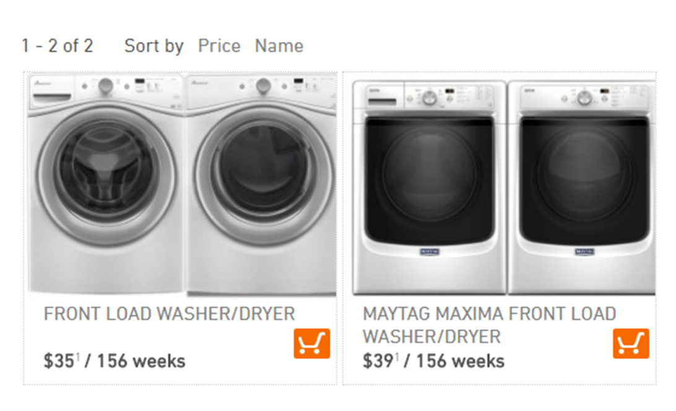
Rent to Own
Electronics Store
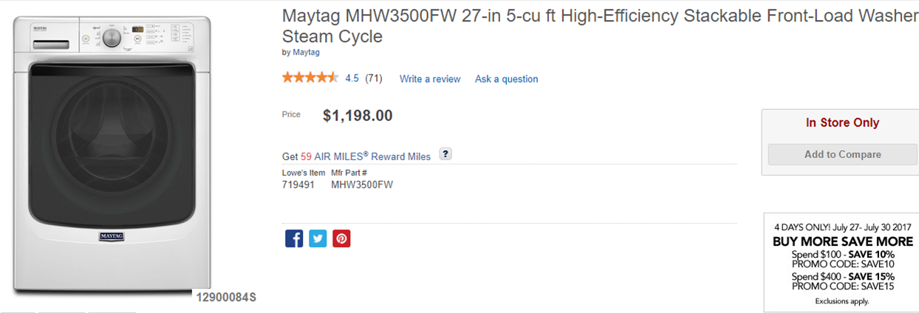

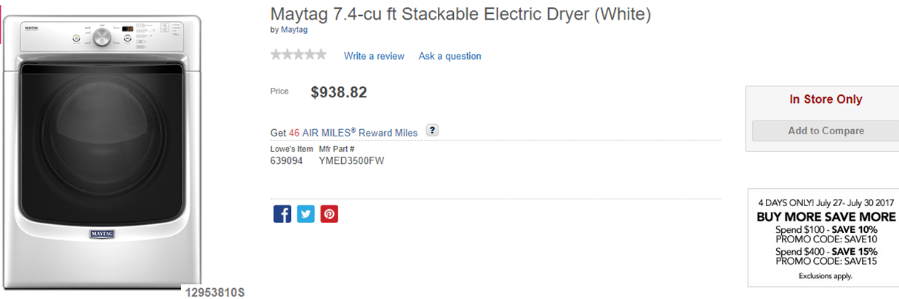
Task Title: Rent to Own - Washer and Dryer
Notes for instructors/facilitators:
Always use the learner’s math from the previous task in the set to mark the next task, as it is about understanding the calculations and just because one number/answer is incorrect it doesn’t mean the next one is automatically wrong just because the numbers used were wrong previously.
Also, important to remember that when dealing with percents you can have a 1 cent difference in HST amounts dependent on how the math is completed.
Answer Key
Task 1: Calculate the total cost of the Maytag Washer/Dryer from the Rent to Own store.
A: $39 x 156 weeks = $6084
Task 2: Calculate the total cost of the Maytag Washer/Dryer from the Rent to Own store including HST.
A: 6084 x 0.13 = 790.92 6084 + 790.92 = $6874.92
Task 3: How much is the total cost of the Maytag Washer/Dryer from the Electronics Store including HST?
A: 1198.00 + 938.82 = 2136.82 2136.82 x 0.13 = 277.79
2136.82 + 277.79 = $2414.61
Task 4: How much is the cost difference between the Rent to Own and the Electronics Store’s Maytag Washer/Dryer?
A: 6874.92 – 2414.61 = 4460.31
Task 5: Calculate how many Maytag Washer/Dryers from the Electronic Store someone could have bought with the total amount of money spent on the Maytag Washer/Dryer at the Rent to Own Store.
A: 6874.92 / 2414.61 = 2.85 (will accept 2 as well)
Task Title: Rent to Own - Washer and Dryer
Performance Descriptors |  | Needs Work | Completes task with support from practitioner | Completes task independently
A2.1 | - scans to locate specific details
 | - interprets brief text and common symbols
 | - locates specific details in simple documents, such as labels and signs
C1.1 | - adds, subtracts, multiplies and divides whole numbers and decimals
 | - identifies and performs required operation
 | - understands numerical order
 | - follows apparent steps to reach solutions
 | - interprets and represents costs using monetary symbols and decimals
 | - uses strategies to check accuracy (e.g. estimating, using a calculator, repeating a calculation, using the reverse operation)
C1.2 | - calculates using numbers expressed as whole numbers, fractions, decimals, percentages and integers
 | - calculates percentages
 | - interprets and applies rates (e.g. $/kg, $/1)
 | - chooses and performs required operation(s); may make inferences to identify required operation(s)
 | - selects appropriate steps to reach solutions
 | - represents costs and rates using monetary symbols, decimals and percentages
 | - uses strategies to check accuracy (e.g. estimating, using a calculator, repeating a calculation, using the reverse operation)

This task: was successfully completed □ needs to be tried again □

Learner Comments

____________________________ _________________________

Instructor (print) Learner Signature

