OALCF Task Cover Sheet
Task Title: Requesting Funds from OW for Special Circumstances
Learner Name:

Date Started: Date Completed:

Successful Completion: Yes___ No___
Goal Path: Employment___ Apprenticeship___ Secondary School___ Post Secondary___ Independence✓
Task Description: Ontario Works recipients sometimes have to request additional one-time funding for special circumstances like buying dress pants for a funeral or winter boots for their children. These requests are usually made over the phone to a case worker. It is important to have proper phone skills and to be organized before making the request. This task requires the learner to write a script and practice phoning a case worker to make a fund request for special circumstances.
Competency:  - Find and Use Information  B. Communicate Ideas and Information | Task Group(s):  A1: Read continuous text  A2: Interpret documents  B1: Interact with others  B3: Complete and create documents
Level Indicators:
A1.2: read texts to locate and connect ideas and information
A2.2: interpret simple documents to locate and connect information
B1.1: Participate in brief interactions to exchange information with one other person
B3.1a: Make straightforward entries to complete very simple documents
Performance Descriptors: see chart on last page
Materials Required:
- Procedure for Requesting One-time Funds sheet
- Walmart flyer ad – attached (if you choose to use an actual flyer, adjust the questions accordingly)
- Phone Etiquette tip sheet
- Pen or pencil
- Task sheet

Instructor Preparation: Provide the learner with a copy of the Procedure for Requesting One-time Funds, the Walmart flyer ad and the Phone Etiquette tip sheet.
Task Title: Requesting Funds from OW for Special Circumstances
Adults on Ontario Works (OW) sometimes need to request additional money from their caseworker for special items such as winter boots for their children. This request is usually made in person or over the phone. It is important that the adult is prepared with information before making the request.

Task 1: You need to get new boots for your son for the winter. He grew two sizes since last winter and is now a size 7. Review the Walmart ad and circle the price for boys’ boots that will fit your son. Understand there is no tax on children’s footwear; calculate how much money you will need to request from the OW office.

Amount to request: $

Task 2: Read the “Procedure for Requesting One-time Funds”. Write down the name and phone number of who to call to make the request for one-time funds.
Name:
Phone Number:
Task 3: Read the Phone Etiquette tip sheet. Highlight or circle all the information on the sheet about the best times to call people. Read the “Procedure for Requesting One-time Funds” and highlight or circle all the information about the OW office hours. Decide what time you will call the OW office to make sure you get to speak to someone.
Time I plan to call:
Task 4: When you call the OW office you want to sound prepared and professional. Fill in the information on the practice script. Refer to the “Procedure for Requesting One-time Funds” to find the information to enter in the blank spaces on the script.

“Hello, my name is . I am calling to speak to about
Can you please connect me to extension ?

Task 5: Read the Phone Etiquette tip sheet and highlight or circle all the information about how to use your voice and to speak properly on the phone. Practice saying the script out loud with your instructor or a partner.
Procedure for Requesting One-time Funds
From the SouthShores Ontario Works Office

OW recipients may request one-time only funds from time to time to cover special circumstances. This may include things like special clothing for a funeral or job interview, weather-related clothing for you or your children, medication or special medical equipment (like crutches) for you or your children.

Before making a request you must have a note from a doctor or a prescription if the money is for medical-related expenses. If the request is for purchasing clothing or other items you should have either a quote from a vendor or proof of the estimated cost. The vendor can be of the client’s choice.

Once you have the proof of cost then phone the SouthShores OW office at 1-888-547-2222 and ask for Jane Connelly at ext. 213. Office hours are Monday-Friday 8:30 am – 4:30 pm. The office is closed for lunch between 12-1 pm but there is an answering machine if you want to leave a message.

You will need to explain your need and what the cost is. Once a request has been approved, a cheque will be issued and the client must show proof of purchase to his/her case worker within 10 days.

Walmart Flyer Page—Winter Boots
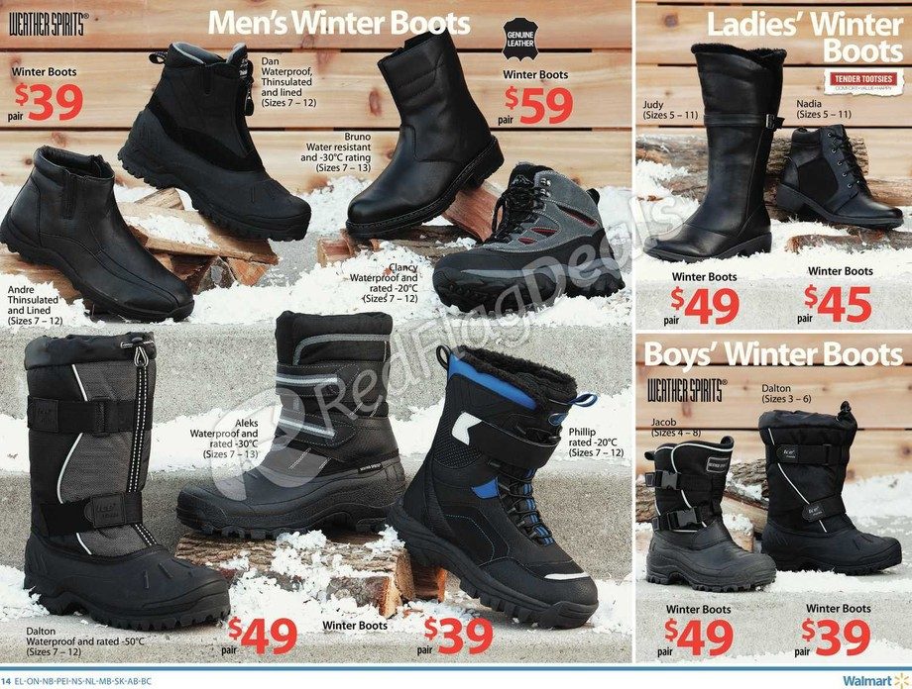

Phone Etiquette

Adapted from ORACLE Think Quest Education Foundation

http://library.thinkquest.org/2993/phone.htm

Calling On the Phone
- Courtesy is as important in speaking over the phone as it is when talking to people face to face. Phone calls generally should not be made before 7:00 in the morning or after 9:30/10:00 at night. Try to avoid mealtimes.
- A person should always be certain of the number he is dialing to avoid disturbing someone unnecessarily. If you do reach a wrong number, it is important to say "I'm sorry, I dialed the wrong number." before hanging up.
- After someone answers the phone, the caller should give his or her name before asking for the person desired.
- When you talk on the telephone, remember:
  - your voice quality
  - express yourself clearly and concisely
- The person at the other end of the phone cannot see your facial expressions or gestures and the impression he receives depends on what she hears. The telephone carries your voice at its natural volume and pitch. Try not to shout but speak clearly and distinctly.

Answering the Phone
- The correct way to answer a telephone is "Hello." "Yes" is abrupt and a bit harsh, but "This is the Doe's house" is a bit vague and "Mrs. Doe speaking" is. . . . well, let's just put it this way, "Hello" is the most proper way to answer the telephone.
- When the telephone in the home is answered by someone other than the head of the house and someone says, "May I speak to Mrs. Brown, please?" he or she should say, "Just a moment, please." If Mrs. Brown is unable to come to the phone, the correct reply is "Mrs. Brown can't come to the phone now. May I have your name, and she will call you back as soon as possible?"
- If you must put the telephone down during the conversation, do it gently, and when you hang up, do it gently. DO NOT SLAM THE RECEIVER DOWN. The person at the other end may still have the phone close to his ear, and then a sudden sharp bang can be hurtful as well as rude.

Common Telephone Courtesy Hints
- Make sure of the correct number so as not to risk disturbing strangers.
- Make sure that your conversations with busy people are as brief as possible.
- When calling friends who do not recognize your voice, announce yourself right away.
- Time your calls so as not to interfere with the work schedule of those you call.
- Make business calls well before the close of the office hours.
- After dialing a wrong number simply say, "Sorry, wrong number."
- When the number you are calling is not answered quickly, wait long enough for someone to put aside what he or she is doing. It is very annoying to have been disturbed just to pick up the telephone and find the caller has hung up.

Task Title: Requesting Funds from OW for Special Circumstances
Performance Descriptors |  | Needs Work | Completes task with support from practitioner | Completes task independently
A1.2 | - scans text to locate information
 | - locates multiple pieces of information in simple texts
 | - makes low-level inferences
A2.2 | - performs limited searches using one or two search criteria
 | - makes connections between parts of documents
 | - makes low-level inferences
B1.1 | - shows an awareness of factors such as social, linguistic and cultural differences that affect interactions in brief exchanges with others
 | - chooses appropriate language in exchanges with clearly defined purposes
 | - participates in short, simple exchanges
 | - gives short, straightforward instructions or directions
 | - speaks or signs clearly in a focused and organized way
B3.1a | - makes a direct match between what is requested and what is entered
This task: was successfully completed___ needs to be tried again___

Learner Comments

____________________________ _________________________
Instructor (print) Learner Signature

