

Task Title: Use Roofing Estimator

# OALCF Cover Sheet – Practitioner Copy

**Learner Name:**

**Date Started:**

**Date Completed:**

|  |  |  |
| --- | --- | --- |
| **Goal Path:** | Employment | Apprenticeship |
| Secondary School | Post Secondary | Independence |

**Successful Completion:**  Yes No 

**Task Description:**

Use a roofing estimator to find information to calculate the amount of roofing supplies to order.

**Main Competency/Task Group/Level Indicator:**

* Find and Use Information/Interpret documents/A2.3
* Use and Understand Numbers/Use measures/C3.3

**Materials Required:**

* Pen & Paper and/or digital device
* Calculator (optional)

# Learner Information

A Roofing Estimator can be used to calculate the amount of roofing supplies to order. Scan the BP Quick Roofing Estimator.

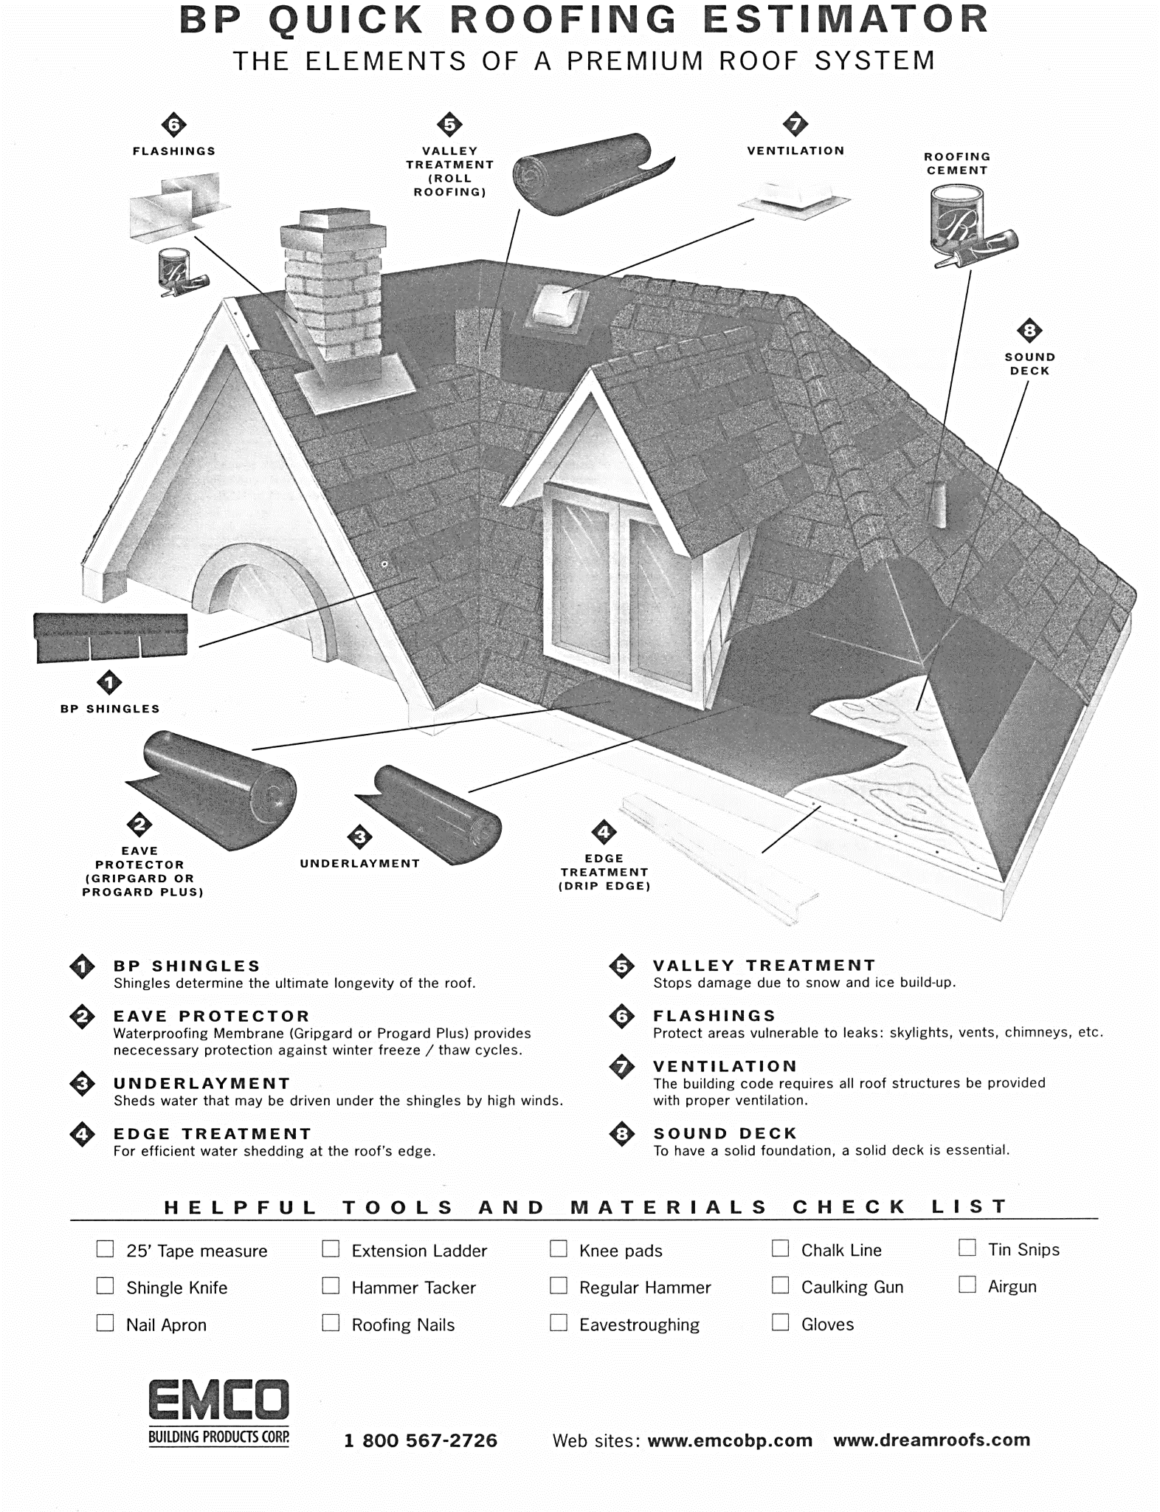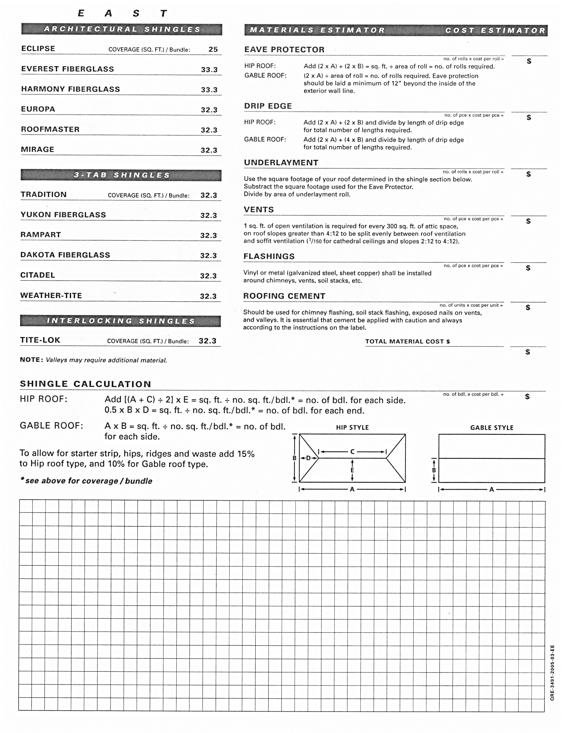

# Work Sheet

**Task 1: What is the purpose of Valley Treatment?**

Answer:

**Task 2: How many types of 3-Tab Shingles are listed?**

Answer:

**Task 3: Locate the Shingle Calculation section on the Estimator. Using the information in the table below, calculate the number of square feet of 1 side of the roof represented in this table.**

|  |  |
| --- | --- |
| **Hip Roof/house Part A** | **32 ft** |
| **Part B** | **18 ft** |
| **Part C** | **14 ft** |
| **Part D** | **10 ft** |
| **Part E** | **10 ft** |

Answer:

**Task 4: Using your calculation in Task 3, calculate how many bundles of 3-Tab shingles will be needed.**

Answer:

**Task 5: If Citadel shingles cost $16.97/bundle, calculate the cost of 11 bundles.**

Answer:

# Answers

**Task 1: What is the purpose of Valley Treatment?**

Answer: to stop damage due to snow and ice buildup

**Task 2: How many types of 3-Tab Shingles are listed?**

Answer: 6 types of shingles

**Task 3: Locate the Shingle Calculation section on the Estimator. Using the information below, calculate the number of square feet on the roof represented in this table.**

|  |  |
| --- | --- |
| **Hip Roof/house A** | **32 ft** |
| **B** | **18 ft** |
| **C** | **14 ft** |
| **D** | **10 ft** |
| **E** | **10 ft** |

Answer:

[(A + C) / 2] x E= sq. feet of roof

[(32 + 14) / 2] x 10 =

230 sq. ft.

**Task 4: Using your calculation in Task 3, calculate how many bundles of shingles will be needed. If necessary, explain your answer.**

Answer:

230 sq. ft. / 32.3 sq ft. per bundle = 7.12 bundles. Since bundles are sold intact, the answer is 8 bundles. *** The answer is correct if the participant used a different number of sq. ft, if they used their answer from Task 3 and did the calculation correctly in Task 4.

*** 8 bundles

**Task 5: If Citadel shingles cost $16.97/bundle, calculate the cost of 11 bundles.**

Answer:

$186.67

# Performance Descriptors

| Levels | Performance Descriptors | Needs Work | Completes task with support from practitioner | Completes task independently |
| --- | --- | --- | --- | --- |
| A2.3 | Uses layout to locate information |  |  |  |
| A2.3 | Manages unfamiliar elements to complete tasks |  |  |  |
| C3.3 | Understands and uses formulas for finding …volume |  |  |  |

This task: Was successfully completed Needs to be tried again 

Learner Comments:

Instructor (print): Learner (print):