

Task Title: Roofing Warranty Facts

# OALCF Cover Sheet – Practitioner Copy

**Learner Name:**

**Date Started:**

**Date Completed:**

|  |  |  |
| --- | --- | --- |
| **Goal Path:** | Employment | Apprenticeship |
| Secondary School | Post Secondary | Independence |

**Successful Completion:**  Yes No

**Task Description:**

Read a document to learn about types of shingles and roofing warranties.

**Main Competency/Task Group/Level Indicator:**

* Find and Use Information/Interpret documents/A2.2-A2.3

**Materials Required:**

* Pen & Paper and/or digital device

# Learner Information

Roofers offer a warranty to homeowners. It covers defects with the roofing materials and workmanship for a specified period. Scan the Warranty Facts document.

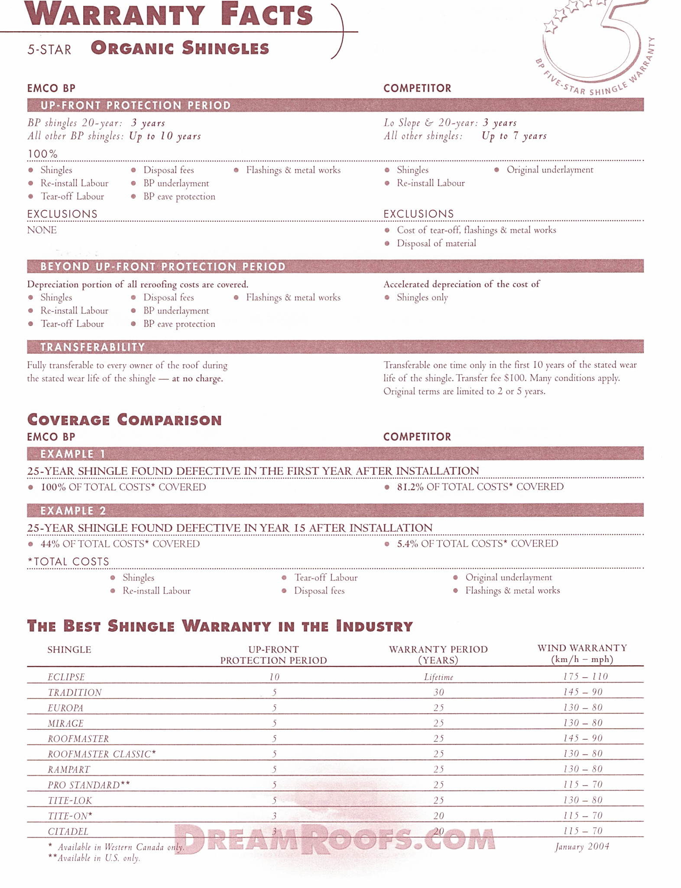

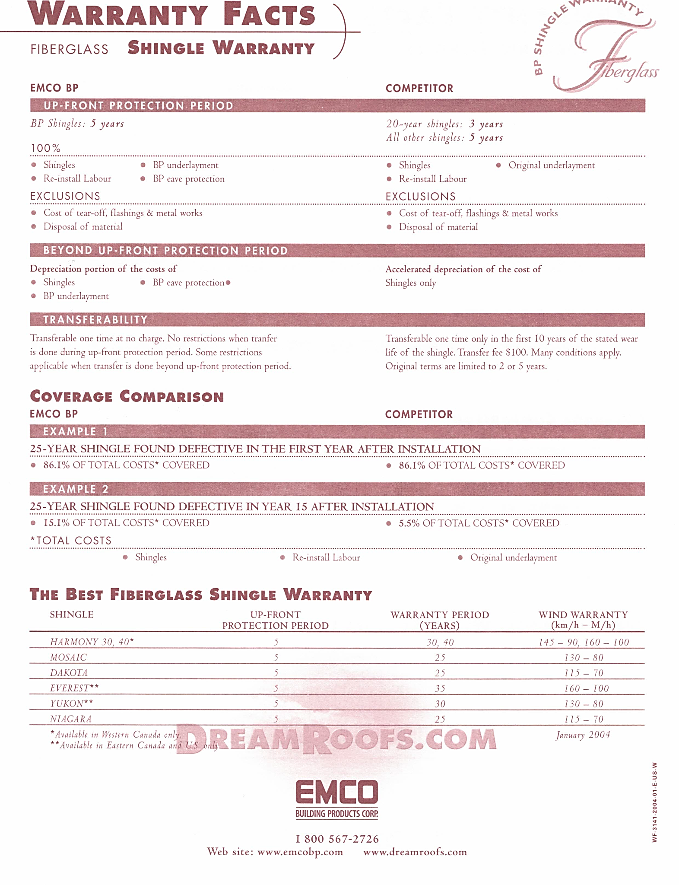

# Work Sheet

**Task 1: List the 2 types of fibreglass shingles that are available only in Eastern Canada and the U.S.**

Answer:

**Task 2: List the 3 warranty categories for each type of shingle.**

Answer:

**Task 3: Which kind of shingle has no exclusions in the warranty through EMCO BP?**

Answer:

**Task 4: Using Example 1 in the coverage comparison of the warranties offered by EMCO BP and its competitor for 25-year organic shingles, explain why EMCO BP has better coverage.**

Answer:

# Answers

**Task 1: List the 2 types of fibreglass shingles that are available only in Eastern Canada and the U.S.**

Answer: Everest and Yukon

**Task 2: List the 3 warranty categories for each type of shingle.**

Answer: Up-front protection period, warranty period, wind warranty

**Task 3: Which kind of shingle has no exclusions in the warranty through EMCO BP?**

Answer: Organic shingles

**Task 4: Using Example 1 in the coverage comparison of the warranties offered by EMCO BP and its competitor for 25-year organic shingles, explain why EMCO BP has better coverage.**

Answer: EMCO BP’s warranty covers a larger portion of the total costs of the roof. In Example 1, EMCO BP covers 100% of the costs compared with the competitor’s coverage of 81.2%.

# Performance Descriptors

| Levels | Performance Descriptors | Needs Work | Completes task with support from practitioner | Completes task independently |
| --- | --- | --- | --- | --- |
| A2.2 | Performs limited searches using one or two search criteria |  |  |  |
| A2.2 | Uses layout to locate information |  |  |  |
| A2.2 | Extracts information from tables and forms |  |  |  |
| A2.3 | Integrates several pieces of information from documents |  |  |  |

This task: Was successfully completed Needs to be tried again

Learner Comments:

Instructor (print): Learner (print):