OALCF Task Cover Sheet
Task Title: Labels for Everyday Health and Safety
Learner Name:

Date Started: Date Completed:

Successful Completion: Yes___ No___
Goal Path: Employment___ Apprenticeship___ Secondary School___ Post Secondary___ Independence √
Task Description:
The learner is required to look at seven warning labels and seven labels found on medications. They will respond orally to various tasks relating to the labels.

Competency:  A: Find and Use Information  B: Communicate Ideas and Information  E: Manage Learning | Task Group(s):  A1: Read continuous text  A2: Interpret Documents  B1: Interact with others  E1:
Level Indicators:
A1.1: Read brief texts to locate specific details
A1.2: Read texts to locate and connect ideas and information
A2.1: Interpret very simple documents to locate specific details
B1.1: Participate in brief interactions to exchange information with one other person
E1: Set short-term goals, begin to use limited learning strategies and begin to monitor own learning
Performance Descriptors: see chart on last page
Materials Required:
- Attached label sheet
- Attached tasks

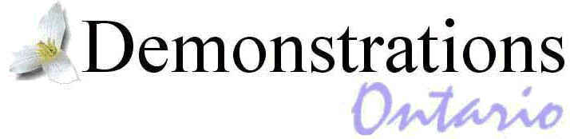
Task Title: Labels for Everyday Health and Safety
PART 1 Understanding what the labels mean

Task 1: Look at the first three labels. What is the reason for these three labels?

Task 2: What should you do if a label says “Avoid contact”?

Task 3: What does “fatal if swallowed” mean?

Task 4: Explain what “external use only” means.

Task 5: Read the medicine labels. Explain what each label tells you to do.

Task 6: Which two labels make you think you should wear rubber gloves when you use that product?

Task 7: Do you think understanding what labels mean and knowing how to use them is:
not very important ____
a little bit important ____
very important ____
Why do you think that?
Task Title: Labels for Everyday Health and Safety
PART 2 Knowing how to use what you know about these labels.

Story 1
Lisa has a three-year-old son.
She keeps all her cleaning products under the sink in the bathroom.
What label tells Lisa to put a product somewhere else?

Story 2
Bill took his medicine at 10:00 a.m. today.
What label tells him when he can take the next dose?
What time can Bill take the next dose?

Self Evaluation:

I recognized _______ out of 13 labels.

I could understand most of the labels. Yes No

I used the pictures to help me decide what the labels mean. Yes No

I was able to explain what the labels mean. Yes No

I recognized and was able to read most of the words. Yes No

I was able to figure out unknown words. Yes No

I liked doing these tasks. Yes No

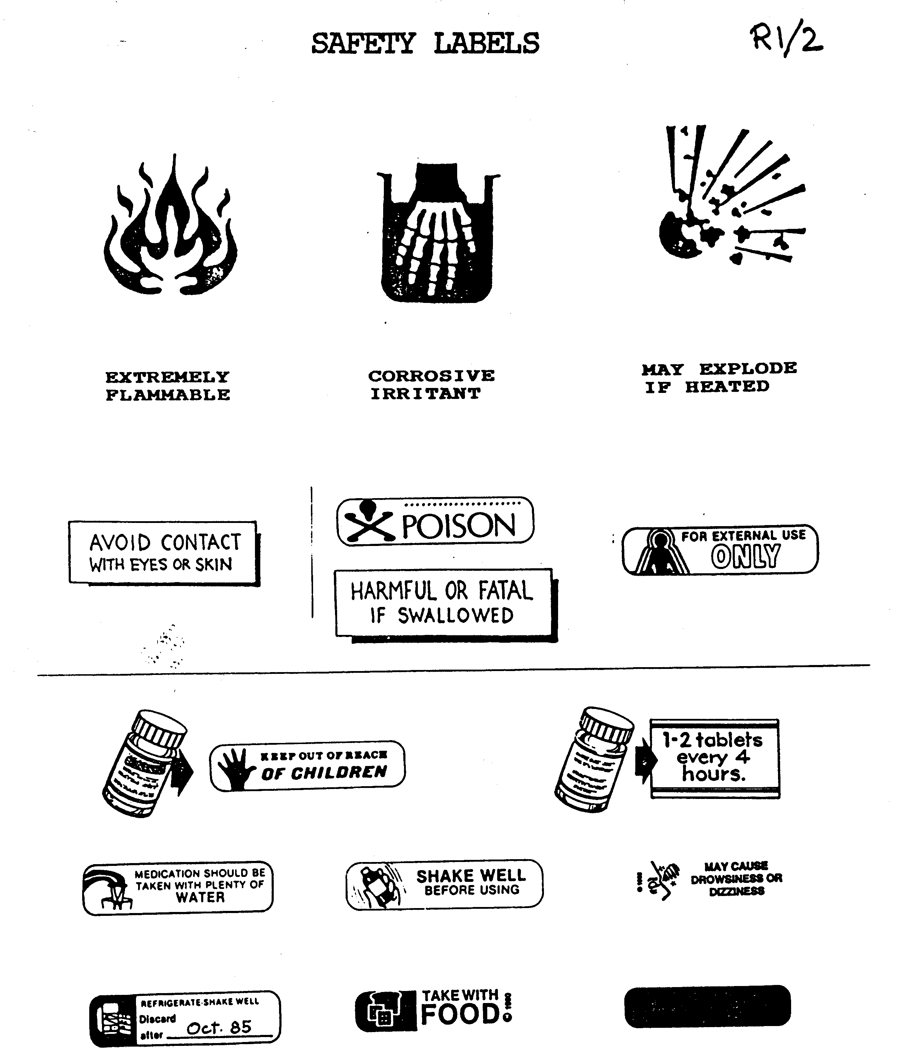
Task Title: Labels for Everyday Health and Safety
Performance Descriptors |  | Needs Work | Completes task with support of practitioner | Completes task independently
A1.1 | - Reads short texts to locate a single piece of information
 | - Follows the sequence of events in straightforward chronological texts
A1.2 | - Locates multiple pieces of information in simple texts
A2.1 | - Scans to locate specific details
 | - Interprets brief text and common symbols
 | - Locates specific details in simple documents, such as labels and signs
B1.1 | - Conveys information on familiar topics
 | - Participates in short, simple exchanges
 | - Speaks or signs clearly in a focused and organized way
E1 | - Begins to monitor progress towards achieving goals
 | - Begins to monitor own learning

This task: was successfully completed___ needs to be tried again___

Learner Comments

____________________________ _________________________

Instructor (print) Learner Signature

