OALCF Task Cover Sheet
Task Title: Take Out Food Purchase
Learner Name:

Date Started: Date Completed:

Successful Completion: Yes___ No___
Goal Path: Employment___ Apprenticeship___ Secondary School___ Post Secondary___ Independence √
Task Description:
Calculating costs and the amount of money left over after sharing a meal with friends.

Competency:  A: Find and Use Information  C: Understand and Use Numbers | Task Group(s):  A2: Interpret documents  C1: Manage money
Level Indicators:
A2.1: Interpret very simple documents to locate specific details
C1.1: Compare costs and make simple calculations

Performance Descriptors: see chart on last page
Materials Required:
- Take Out Menu (Local take-out menus can be substituted for the one in the task)
- Pencil/pen

Task Title: Take Out Food Purchase
Take out from Vito’s

Three families get together once a month for a takeout dinner and videos. This month it is the Closs family’s turn to host, and they pick up the following meals:

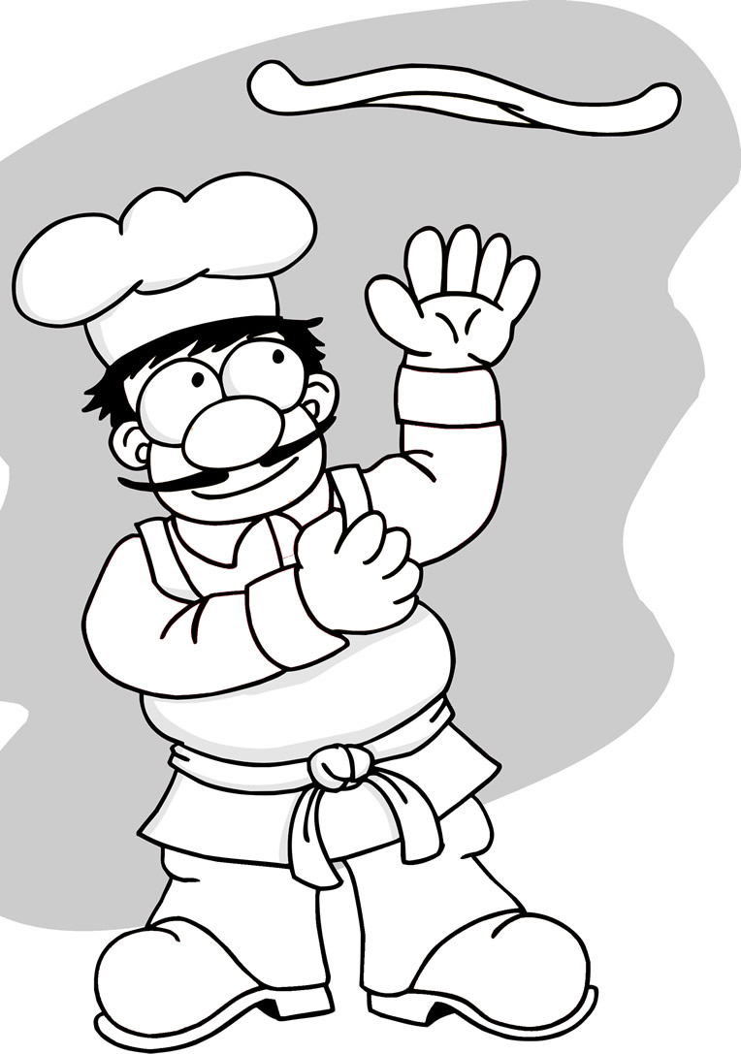
Closs family wants
Pizza and Wing Combo
Large pizza (3 toppings)
& 20 wings
$20.95
Pizza /Chicken
Family Meal
$20.99
2 Pasta Dishes
$8.95
With Garlic bread
- four pasta dishes with garlic bread

Devlin family wants
- one pizza and wing combo

Emerson family wants
- pizza/chicken family meal

Vito’s Take Out
Task 1: How much will the dinners cost for each family? Do your calculations on this paper.

Closs Family:

Devlin Family:

Emerson Family:

Task 2: How much will the dinner cost for all 3 families in total?

Task 3: Rob Closs also stops to get videos for both the kids and for the parents. This comes to $6.88. If he started out with $80, how much will he have left after renting the videos and all of the food?

Answers
Task 1: How much will the dinners cost for each family? Do your calculations on this paper.

Closs Family: 2 pasta dishes with garlic bread @ 8.95 = $17.90

Devlin Family: 1 pizza & wing combo = $20.95

Emerson Family: 1 pizza/chicken family meal = $20.99

Task 2: How much will the dinner cost for all 3 families in total?

17.90+20.95+20.99= $59.84

Task 3: Rob Closs also stops to get videos for both the kids and for the parents. This comes to $6.88. If he started out with $80, how much will he have left after buying the videos and dinners?

59.84+6.88 = 66.72
80.00 – 66.72 = $13.28

Task Title: Take Out Food Purchase
Performance Descriptors |  | Needs Work | Completes task with support from practitioner | Completes task independently
A2.1 | - scans to locate specific details
 | - interprets brief text and common symbols
 | - locates specific details in simple documents, such as labels and signs
C1.1 | - adds, subtracts, multiplies and divides whole numbers and decimals
 | - recognizes values in number and word format
 | - identifies and performs required operation
 | - follows apparent steps to reach solutions
 | - interprets and represents costs using monetary symbols and decimals
 | - uses strategies to check accuracy (e.g. estimating, using a calculator, repeating a calculation, using the reverse operation)

This task: was successfully completed___ needs to be tried again___

Learner Comments

____________________________ _________________________

Instructor (print) Learner Signature

