OALCF Task Cover Sheet
Task Title: Technical Service Bulletins
Learner Name:

Date Started: Date Completed:

Successful Completion: Yes___ No___
Goal Path: Employment___ Apprenticeship ✓ Secondary School Post Secondary Independence__
Task Description:
Understand how to use the internet to search a database to locate and use information related to technical service bulletins.
Competency:  A: Find and Use Information  B: Communicate Ideas and Information  D: Use Digital Technology | Task Group(s):  A1: Read continuous text  A2: Interpret Documents  B2: Write continuous text  D2: Use Digital Technology
Level Indicators:
A1.1: Read brief texts to locate specific details
A2.2: Interpret simple documents to locate and connect information
B2.2: Write texts to explain and describe information and ideas
B2.3: Write longer texts to present information, ideas and opinions
D2: Perform well-defined, multi-step digital tasks

Performance Descriptors: see chart on last page
Materials Required:
- Computer with internet access
- Pen and paper

Task Title: Technical Service Bulletins
Automotive service technicians receive technical service bulletins from automotive manufacturers. They are required to read and incorporate the information from the product issues described on the bulletins into everyday practice.
Learner Information and Tasks:
Task 1: Go to the Ford Trucks website, www.ford-trucks.com/tsb/fulltext, and locate the Technical Services bulletins Full Text for Ford F-150, model year 2010 Ford trucks.

Task 2: Using bulletin 09-23-7, explain in your own words the issue expressed in this bulletin.

Task 3: Using bulletin 09-23-7, list all of the vehicles this bulletin applies to.

Task 4: Using the technical service bulletins (TSB) main page, select any other model and recall notice and explain in your own words the issue expressed in the bulletin.

Task Title: Technical Service Bulletins
Answer Key
Task 1: - Open the internet
- Use a search engine, such as Google, to search “www.ford-trucks.com/tsb/fulltext”
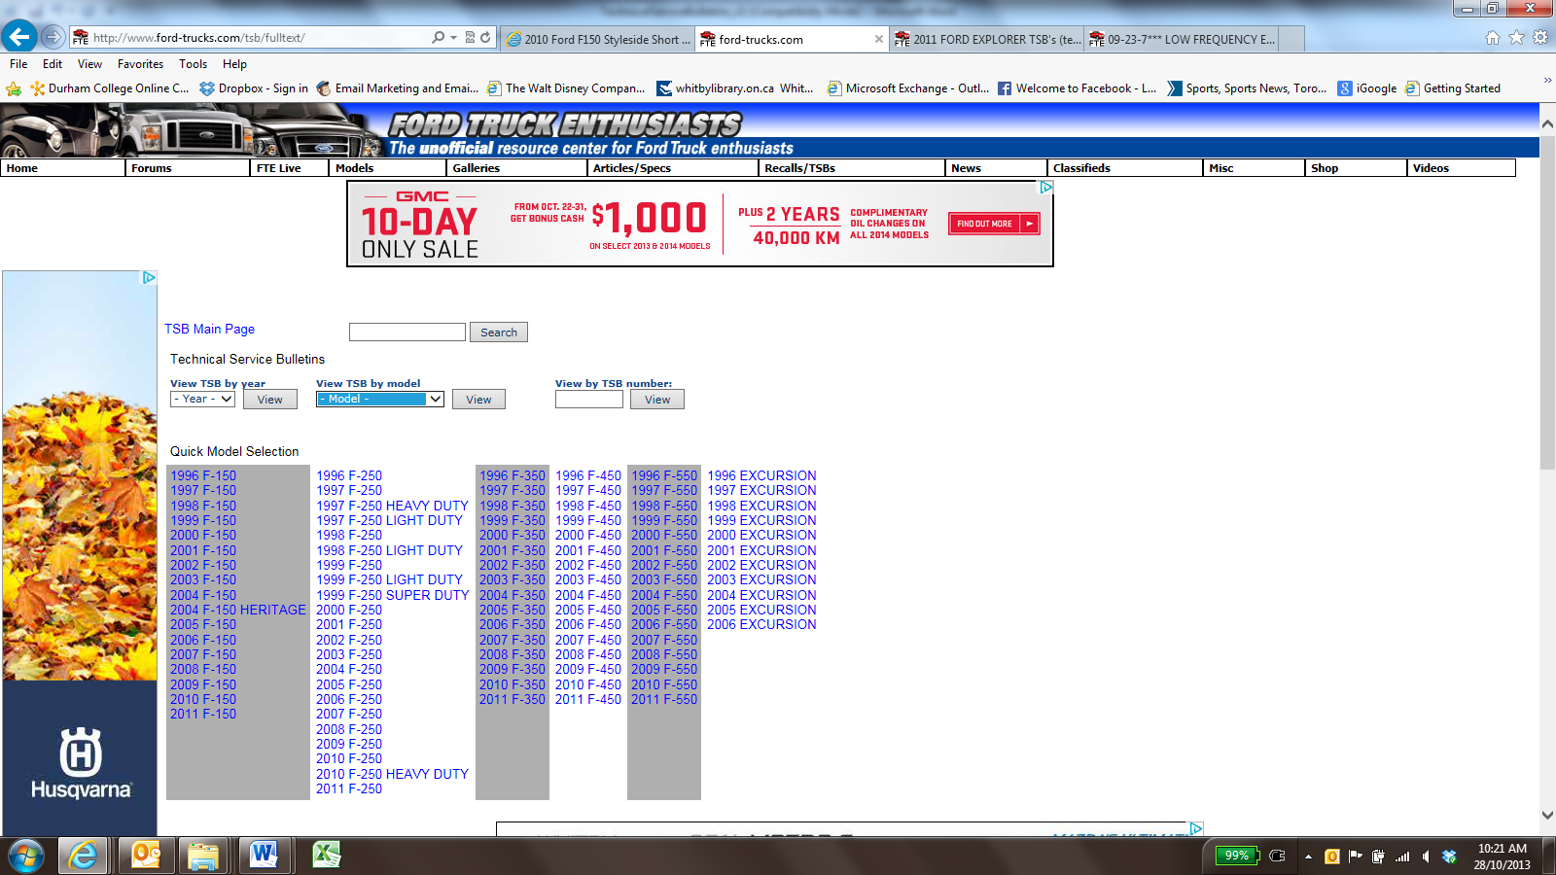
(Image as of October 2013)
- Use the “Quick Model Selection” to find “2010 F-150” located in the far-left column.
- Click on “2010 F-150”
- Using the technical services bulletin (TSB) main page, locate “09-23-7 (Low Frequency Knocking Noise At Hot Idle”
- Click on “09-23-7” link
- 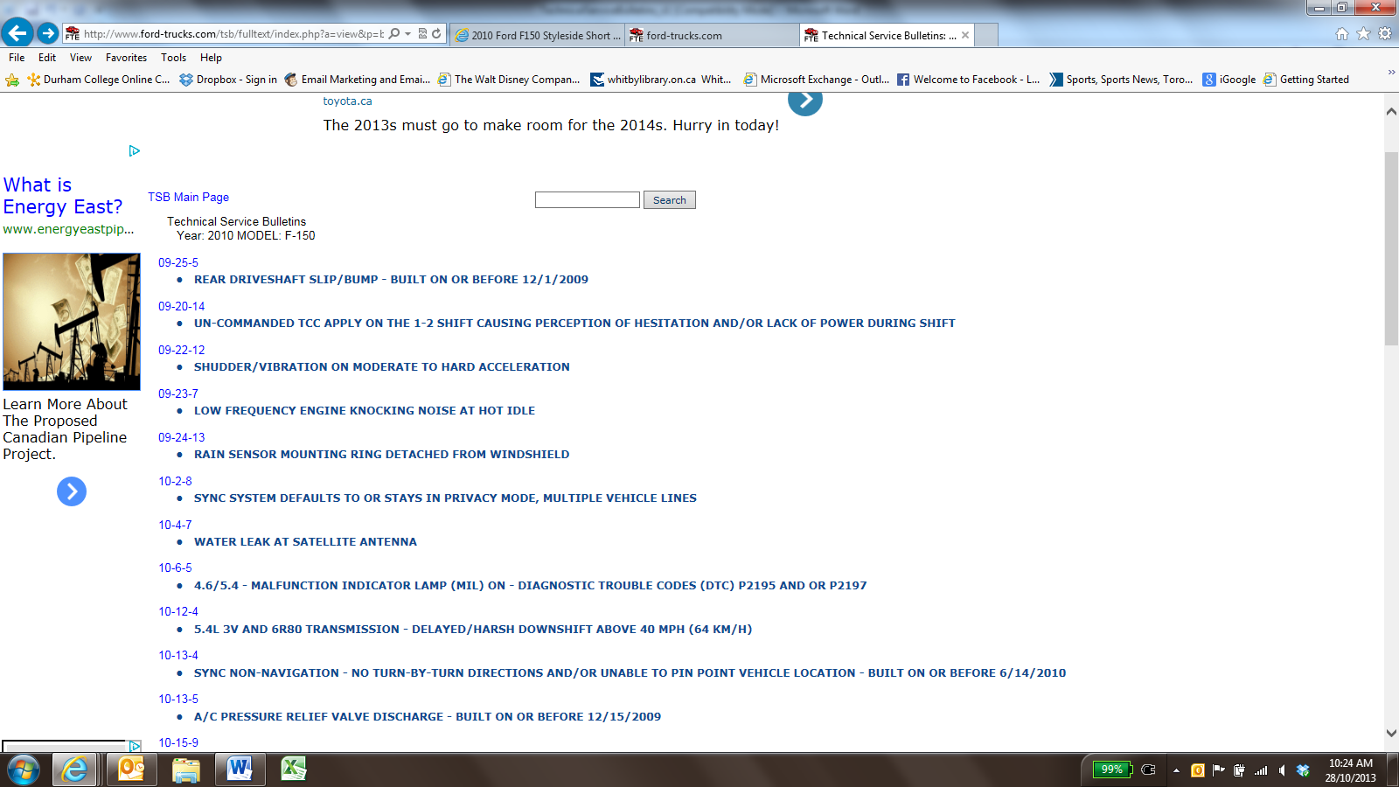
(Image as of October 2013)
Task 2: Answers will vary but should include reference to:
- Vehicles equipped with a 4.6L 3V or 5.4L 3V engine
- Vehicles may exhibit a low frequency knocking noise
- Noise predominately heard from right front wheel are or right hand engine cam cover
- Noise may be generated from the right hand variable camshaft timing

Task 3: 2009-2010 Ford Expedition, F-150 and 2009-2010 Lincoln Navigator

Task 4: Answers will vary, but should include reference to the vehicle model selection, technical service bulleting number, and bulletin notes

Task Title: Technical Service Bulletins
Performance Descriptors |  | Needs Work | Completes task with support from practitioner | Completes task independently
A1.1 | - reads short texts to locate a single piece of information
 | - decodes words and makes meaning of sentences in a single text
 | - follows the sequence of events in straightforward chronological texts
 | - follow simple, straightforward instructional texts
 | - identifies the main idea in brief texts
A2.2 | - performs limited searches using one or two search criteria
 | - extracts information from tables and forms
 | - locates information in simple graphs and maps
 | - uses layout to locate information
 | - makes connections between parts of documents
 | - makes low-level inferences
B2.2 | - writes texts to explain and describe
 | - conveys intended meaning on familiar topics for a limited range of purposes and audiences
 | - uses limited range of vocabulary and punctuation appropriate to the task
 | - begins to select words and tone appropriate to the task
 | - begins to organize writing to communicate effectively
B2.3 | - writes texts to present information, summarize, express opinions, present arguments, convey ideas or persuade
 | - manages unfamiliar elements (e.g. vocabulary, context, topic) to complete tasks
 | - selects and uses vocabulary, tone and structure appropriate to the task
 | - organizes and sequences writing to communicate effectively
D2 | - selects and follows appropriate steps to complete tasks
 | - locates and recognizes functions and commands
 | - makes low-level inferences to interpret icons and text
 | - begins to identify sources and evaluate information
 | - performs simple searches using keywords (e.g. internet, software help menu)

This task: was successfully completed___ needs to be tried again___

Learner Comments

____________________________ _________________________

Instructor (print) Learner Signature

