Task-based Activity Cover Sheet
Task Title: Tracking Height and Weight Percentiles
Learner Name:

Date Started: Date Completed:

Successful Completion: Yes___ No___
Goal Path: Employment ✓ Apprenticeship___ Secondary School Post Secondary Independence ✓
Task Description:
The learner will use height and weight percentile charts to monitor a child’s growth over time.
Competency:  C: Understand and Use Numbers  A: Find and Use Information | Task Group(s):  C4: Manage Data  A2: Interpret Documents
Level Indicators:
C4.3: Find, integrate and analyze data; identify trends in data
A2.3: Interpret somewhat complex documents to connect, evaluate and integrate information
Performance Descriptors: see chart or click here
Skill Building Activities: see last page or click here
Materials Required:
- Pen/pencil
- Attached charts
ESKARGO:
- Manages unfamiliar elements (context, content) to complete tasks
- Makes estimates involving many factors where precision is required
- Begins to recognize bias in data and in displays, such as graphs
- Identifies a variety of ways to complete tasks
- Finds, integrates, and analyses data
- Organizes and represents numerical information (e.g., tables, graphs)
- Makes predictions using data; identifies trends
- Uses strategies to check accuracy

Attitudes:
Practitioner,
We encourage you to talk with the learner about attitudes required to complete this task set. The context of the task has to be considered when identifying attitudes. With your learner, please check one of the following:
□ Attitude is not important □ Attitude is somewhat important □ Attitude is very important

Task Title: Tracking Height and Weight Percentiles
Some health care professionals use height and weight percentile charts as one of their guidelines to monitor a child’s growth.
Look at the “Birth to 36 months: Boys” and the “Girls, birth to 36 months” growth charts.
Learner Information and Tasks:
Task 1: a) Plot the following weight information on the “Birth to 36 months: Boys” percentiles chart:
Birth | 8 lb 3 oz |  | 21 months | 26 lb 7 oz
3 months | 12 lb 8 oz |  | 24 months | 27 lb 6 oz
6 months | 16 lb |  | 27 months | 28 lb 4 oz
9 months | 20 lb 15 oz |  | 30 months | 29 lb 1 oz
12 months | 22 lb 1 oz |  | 33 months | 30 lb 4 oz
15 months | 24 lb |  | 36 month | 31 lb 8 oz
18 months | 25 lb 14 oz

b) Plot the same weights on the “Weight-for-age percentiles: Girls birth-36 months” chart.
c) What difference do you notice between the lines you have created on the two charts?

Task Title: Tracking Height and Weight Percentiles

Task 2: a) Plot the following height information on the “Birth to 36 months: Boys” percentiles chart:
Birth | 21 ½” |  | 21 months | 33 ¾”
3 months | 24 ¾” |  | 24 months | 34 ½”
6 months | 27” |  | 27 months | 36 ¼”
9 months | 29” |  | 30 months | 37”
12 months | 30 ½” |  | 33 months | 38 ½”
15 months | 31 ½” |  | 36 month | 39 ½”
18 months | 32”

b) What percentile would this child fall into?
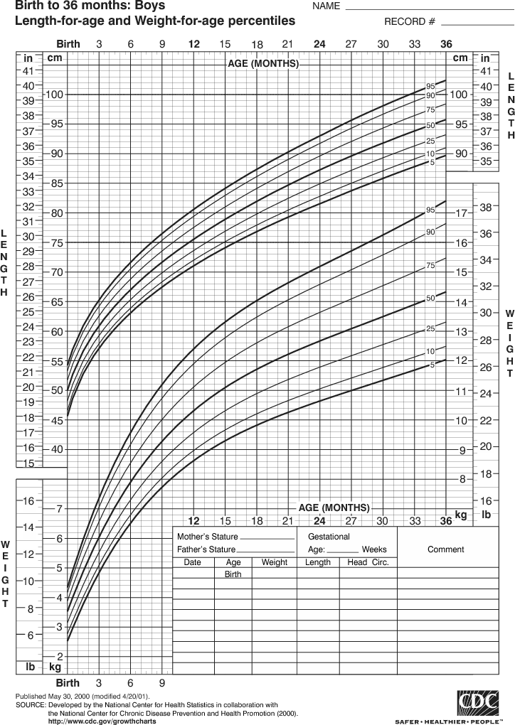
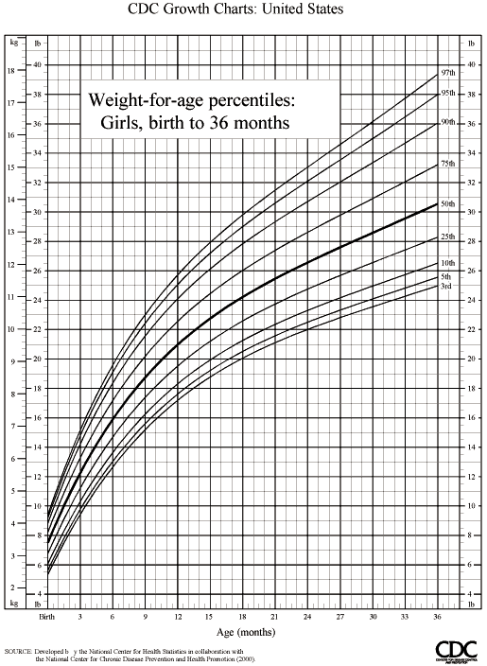
Task Title: Tracking Height and Weight Percentiles
Answer Key
Task 1: a) Plot the following weight information on the “Birth to 36 months: Boys” percentiles chart:
see chart
b) Plot the same weights on the “Weight-for-age percentiles: Girls birth-36 months” chart.
see chart
c) What difference do you notice between the two charts?
Their answer should indicate that a girl will be in a higher percentile than a boy of the same age and weight.
Task 2: a) Plot the following height information on the “Birth to 36 months: Boys” percentiles chart:
see chart
b) This child would fall into the 91st percentile. (90 to 93 is acceptable)

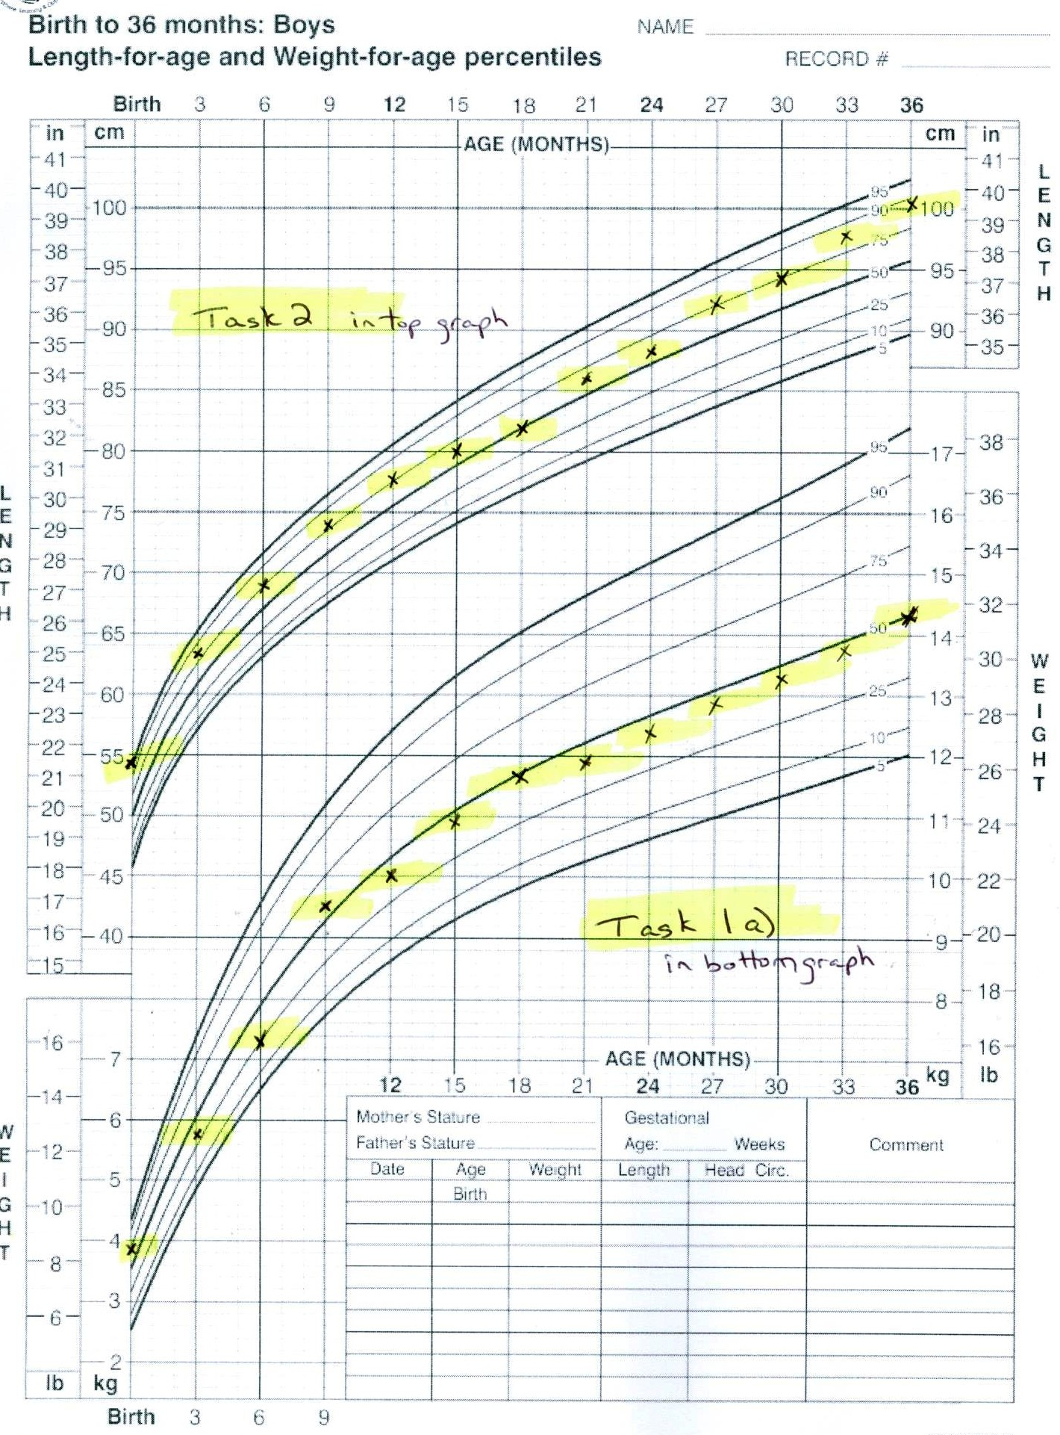
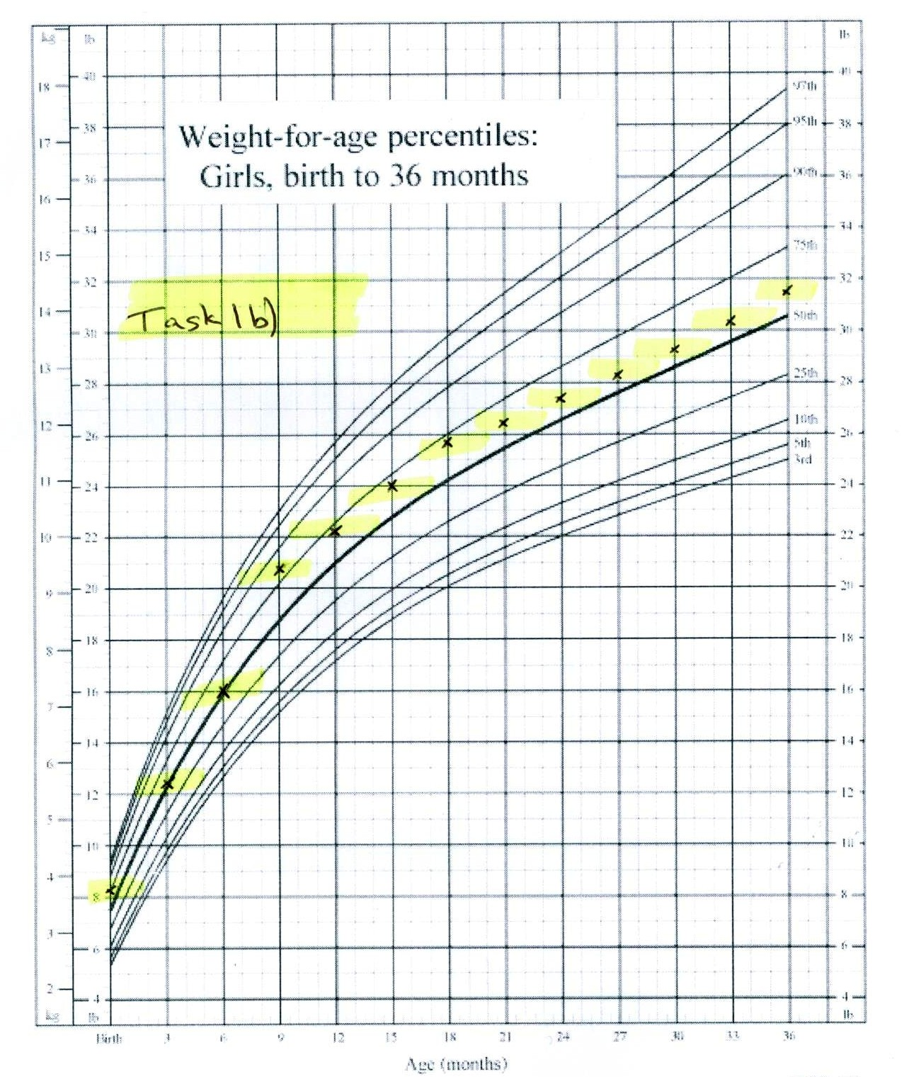

Task Title: Tracking Height and Weight Percentiles
Performance Descriptors |  | Needs Work | Completes task with support from practitioner | Completes task independently
C4.3 | - manages unfamiliar elements (e.g. context, content) to complete tasks
 | - makes estimates involving many factors where precision is required
 | - begins to recognize bias in data and in displays, such as graphs
 | - selects appropriate steps to solutions from among options
 | - interprets, represents and converts values using whole numbers, decimals, percentages, ratios and fractions
 | - finds integrates and analyzes data
 | - organizes and represents numerical information (e.g. tables, graphs)
 | - makes predictions using data; identifies trends
A2.3 | - manages unfamiliar elements (e.g. vocabulary, context, topic) to complete tasks
 | - compares or contrasts information between two or more documents
 | - uses layout to locate information
 | - makes inferences and draws conclusions from information displays
This task: was successfully completed___ needs to be tried again___

Learner Comments

____________________________ _________________________

Instructor (print) Learner Signature

Skill Building Activities
Links to online resources:
https://www.khanacademy.org/science/health-and-medicine/healthcare-misc/v/childhood-growth
Childhood Growth Chart Explained (12 min)
https://www.youtube.com/watch?v=Cyae-zAilLs
Learn how to interpret infant growth chart guidelines from pediatrician (1.38 min)

https://www.youtube.com/watch?v=GUYRMdcEs00
Graphing by Hand (5.38 Min)

LearningHUB online courses available:
- Math, Independent Study (Assigned by practitioner after assessment) :
  - Data Analysis Assignment; Measurement Assignment; Percentages & Mixed Operations Asg.2
- Essential Skills, Independent Study (Assigned by practitioner after assessment):
  - Document Use Level 2 Asg. 2; Document Use Level 3 Asg. 1

  - Live Classes (SABA) : Percentages A; Percentages B
*To access LearningHUB courses, learners must register for the LearningHUB e-Channel program by completing the registration form on their website and completing the course selection (page 2 of the registration form): https://www.learninghub.ca/get_registered.aspx
*To Access LearningHUB Course Catalogue:
http://www.learninghub.ca/Files/PDF-files/HUBcoursecatalogue,%20December%2023,%202014%20revision.pdf

