

Task Title: Understanding Health Benefits Packages

# OALCF Cover Sheet – Practitioner Copy

**Learner Name: __________________________________________**

**Date Started: ___________________________________________**

**Date Completed: _________________________________________**

|  |  |  |
| --- | --- | --- |
| **Goal Path:** | Employment | Apprenticeship |
| Secondary School | Post Secondary | Independence |

**Successful Completion:**  Yes No

**Task Description:** The learner will compare health benefits packages offered by Sun Life.

**Main Competency/Task Group/Level Indicator:**

* Find and Use Information/Interpret documents/A2.1

**Materials Required:**

* Pen/pencil and paper and/or digital device

# Learner Information

The Ontario Health Insurance Plan (OHIP) covers most healthcare expenses, but it doesn’t cover everything. Many people have additional workplace insurance coverage for things like dental care, vision care and prescription drugs. Employees who have a workplace insurance plan should make sure they understand what is covered so they can make the most use of their benefits.

Review “Sun Life Health Coverage Choices”.

**Sun Life Health Coverage Choices**

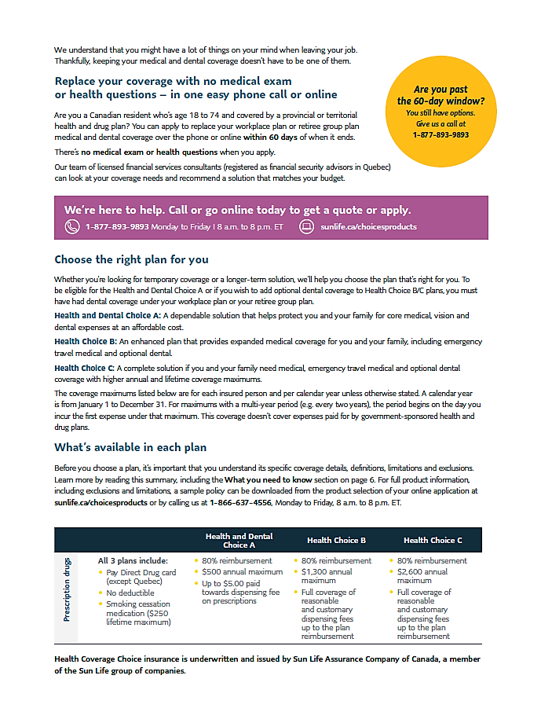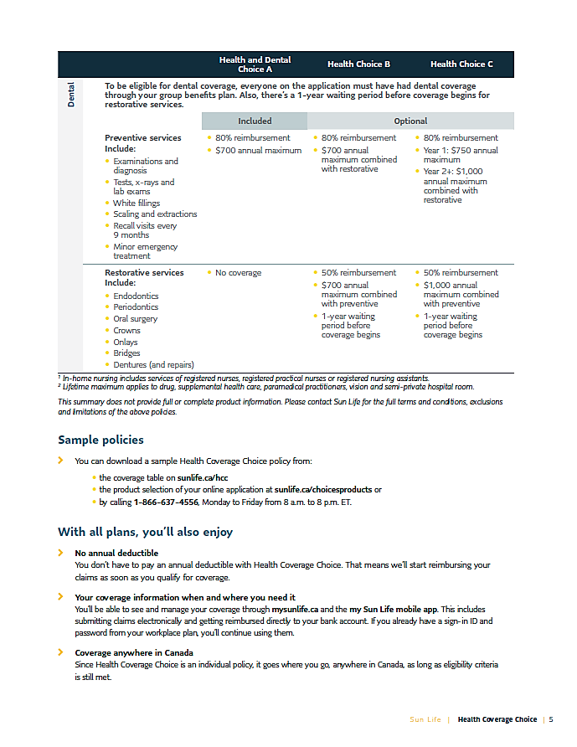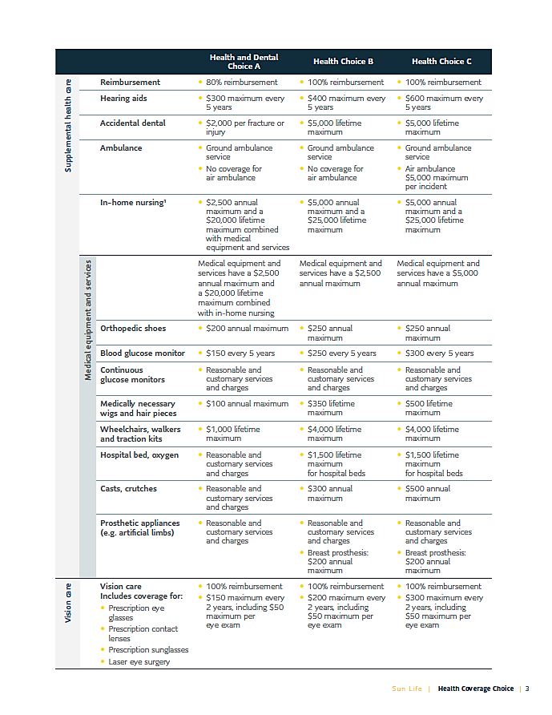

# Work Sheet

**Task 1: Which plans have an 80% reimbursement for prescription drugs?**

Answer:

**______________________________________________________**

**Task 2: Which plan has a $700 annual maximum for Preventative dental services?**

Answer:

**______________________________________________________**

**Task 3: Which vision plans reimburse more than $150 every 2 years for prescription glasses, contact lenses, or eye surgery?**

Answer:

**______________________________________________________**

**Task 4: List four services included in Restorative dental services.**

Answer:

**______________________________________________________**

# Answers

**Task 1: Which plans have an 80% reimbursement for prescription drugs?**

Answer: All three plans: Health and Dental Choice A, Health Choice B, and Health Choice C.

**Task 2: Which plan has a $700 annual maximum for preventative dental services?**

Answer: Health and Dental Choice A

**Task 3: Which vision plans reimburse more than $150 every 2 years for prescription glasses, contact lenses, or eye surgery?**

Answer: Health Choice B and Health Choice C.

**Task 4: List four services included in Restorative dental services.**

Answer: Any four of the following:

* Endodontics
* Periodontics
* Oral Surgery
* Crowns
* Onlays
* Bridges
* Dentures (and repairs)

# Performance Descriptors

| Levels | Performance Descriptors | Needs Work | Completes task with support from practitioner | Completes task independently |
| --- | --- | --- | --- | --- |
| A2.1 | scans to locate specific details |  |  |  |
|  | interprets brief text and common symbols |  |  |  |
|  | identifies how lists are organized (e.g. sequential, chronological, alphabetical) |  |  |  |

This task: Was successfully completed Needs to be tried again

Learner Comments:

Instructor (print): Learner (print):

**__________________ _________________**