

Task Title: Use a Database for Researching Employment Information

# OALCF Cover Sheet – Practitioner Copy

**Learner Name: __________________________________________**

**Date Started:** **___________________________________________**

**Date Completed: _________________________________________**

|  |  |  |
| --- | --- | --- |
| **Goal Path:** | Employment | Apprenticeship |
| Secondary School | Post Secondary | Independence |

**Successful Completion:**  Yes No 

**Task Description:** The learner will learn how to use a job search database to research employment information.

**Main Competency/Task Group/Level Indicator**

* Find and Use Information/Read continuous text/A1.2
* Find and Use Information/Interpret documents/A2.2
* Use Digital Technology/D.2

**Materials Required:**

* Pen/pencil and paper
* Computer or digital device

# Learner Information

The Government of Canada organizes occupations into different categories. This is called the “National Occupational Classification” coding system. Understanding how this system works can make it easier to research jobs.

Scan “How to Use a Database for Researching Employment Information”.

## **How to Use a Database for Researching Employment Information**

What is a database? It is a collection of pieces of information presented in an organized manner, usually on a computer.

Databases are used for searching for information important to the user. For example, the search engine used to locate websites is an organized database. Websites may be organized by name, content or location. Different search engines have different search criteria.

When you type in a word or several words for searching these are called keyword searches and the database will display information related to those words.

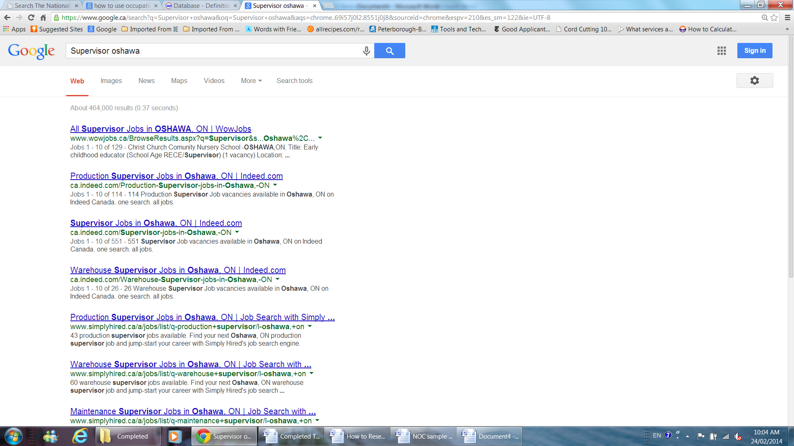When searching for a job or doing research related to an occupation you may use the job title and location. When using an occupational database, the criteria for searching may be specific to the organization of the database. If there is a search word in the selection that you do not understand use the websites help feature to locate the meaning. Most websites will have a help feature located on each page.

For example, "Supervisor, Oshawa", these are the two words that the search engine will look for and display. The sample shows a number of results for these two words.

When searching for something on a website there may be different types of ways to search, such as dropdown lists, check boxes or a list with radio buttons to be selected.

Dropdown list Radio Button Checkbox

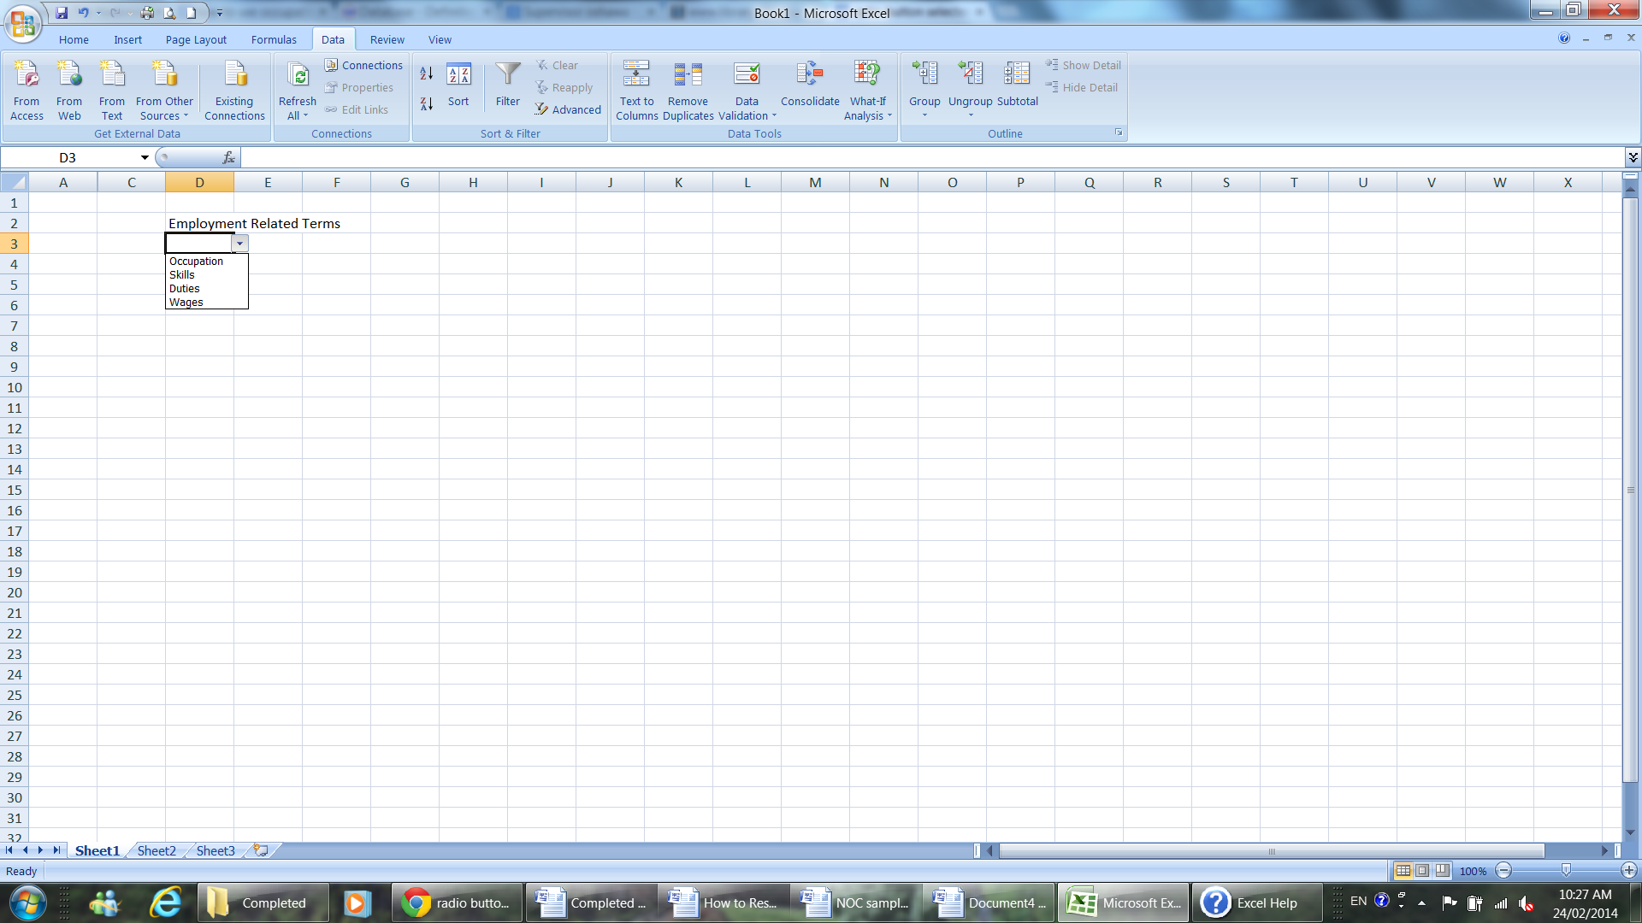 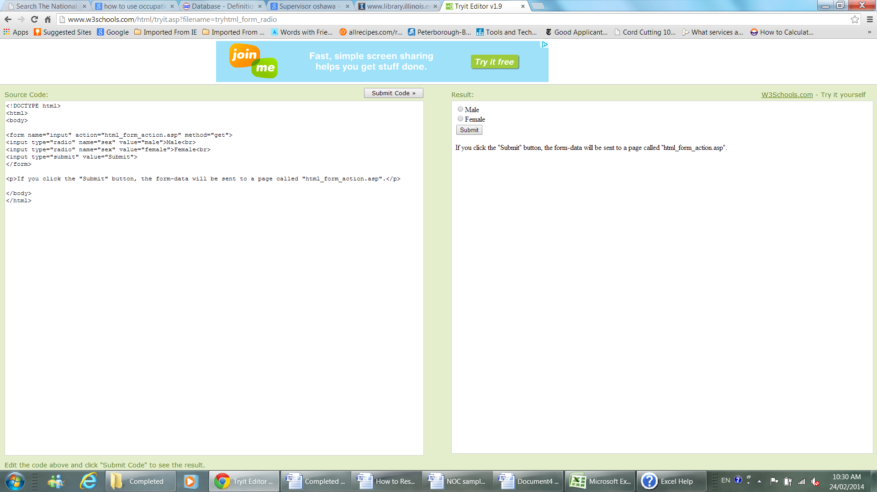 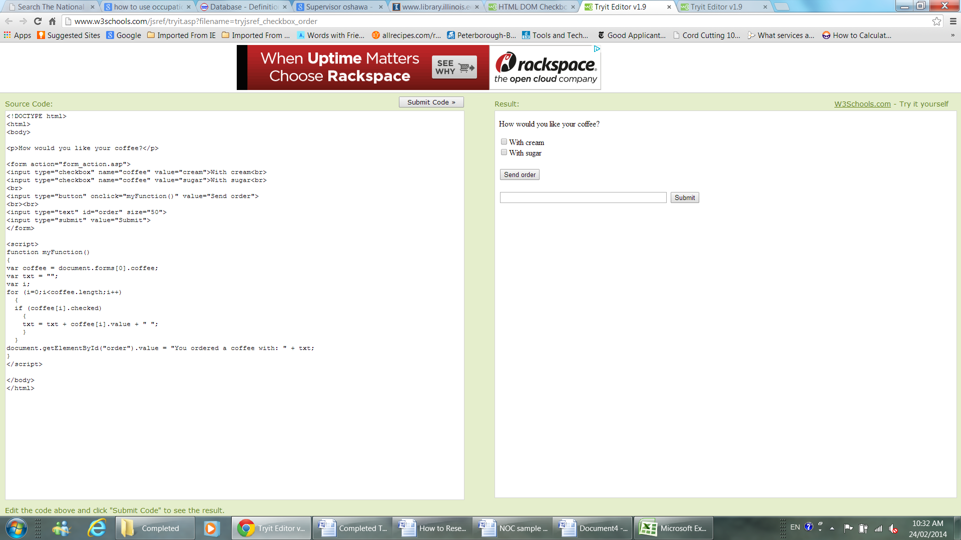

# Work Sheet

**Task 1: Go to National Occupational Classification website:** [**https://noc.esdc.gc.ca/**](https://noc.esdc.gc.ca/)**. What are the two ways you can search for jobs?**

Answer:

**______________________________________________________**

**Task 2: What are three different versions searchable in the dropdown list?**

Answer:

**______________________________________________________**

**Task 3: Select the job title search method and enter the job title “production manager”. How many job titles for production manager are displayed in the search results?**

Answer:

**______________________________________________________**

**Task 4: Open a new page on the web browser. Conduct a Google search for “What is a NOC code.” Write the meaning of NOC code here.**

Answer:

**______________________________________________________**

# Answers

**Task 1: What are the two ways you can search for jobs?**

Answer: Search by job title or search by NOC code.

**Task 2: What are three different versions searchable in the dropdown list?**

Answer: Any three of:

NOC 2021 Version 1.0, NOC 2016 Version 1.3, NOC 2011 Version 1.0, NOC 2006 Version 1.

**Task 3: Select the job title search method and enter the job title “production manager”. How many job titles for production manager are displayed in the search results?**

Answers will vary depending on when the search is conducted.

**Task 4: Open a new page on the web browser. Conduct a Google search for “What is a NOC code.” Write the meaning of NOC code here.**

Answer: The National Occupational Classification (NOC) is the national reference for occupations in Canada. It provides a systematic classification structure that categorizes the entire range of occupational activity in Canada for collecting, analyzing, and disseminating occupational data for labour market information and employment-related program administration.

# Performance Descriptors

| Levels | Performance Descriptors | Needs Work | Completes task with support from practitioner | Completes task independently |
| --- | --- | --- | --- | --- |
| A1.2 | scans text to locate information |  |  |  |
|  | locates multiple pieces of information in simple texts |  |  |  |
|  | makes connections between sentences and between paragraphs in a single text |  |  |  |
|  | follows the main events of descriptive, narrative and informational texts |  |  |  |
|  | obtains information from detailed reading |  |  |  |
| A2.2 | performs limited searches using one or two search criteria |  |  |  |
|  | uses layout to locate information |  |  |  |
|  | makes connections between parts of documents |  |  |  |
|  | makes low-level inferences |  |  |  |
| D.2 | selects and follows appropriate steps to complete tasks |  |  |  |
|  | locates and recognizes functions and commands |  |  |  |
|  | makes low-level inferences to interpret icons and text |  |  |  |
|  | begins to identify sources and evaluate information |  |  |  |
|  | performs simple searches using keywords (e.g. internet, software help menu) |  |  |  |

This task: Was successfully completed Needs to be tried again 

Learner Comments:

Instructor (print): Learner (print):

# **____________________ _____________________**