Task-based Activity Cover Sheet
Task Title: Carpenter Using Construction Design Software
Learner Name:

Date Started: Date Completed:

Successful Completion: Yes___ No___
Goal Path: Employment✓ Apprenticeship✓ Secondary School Post Secondary Independence___
Task Description:
Carpenters use construction 3D design software to create and modify plans based on what the customer wants.
Competency:  A: Find and Use Information  C: Understand and Use Numbers  D: Use Digital Technology | Task Group(s):  A2: Interpret documents  A3: Extract info from films, broadcasts and presentations  C3: Use measures
Level Indicators:
A2.2: Interpret simple documents to locate and connect information
C3.3: Use measures to make multi-step calculations; use specialized measuring tools
D.2: Perform well-defined, multi-step digital tasks
Performance Descriptors: see chart on last page
Materials Required:
- Digital device with internet access
- Pen or pencil
- Calculator

Task Title: Carpenter Using Construction Design Software
Carpenters use 3D design software to plan and communicate ideas with customers. They use the design software to develop models to show clients to save time and plan.
Learner Information and Tasks:
Open a browser and perform a keyword search to find SketchUp 3D design software. Select the “getting started video” link and watch Part 1.
Task 1: How do you start and finish each action with your mouse?

Task 2: What measurement system is being used, according to the Distance indicator?

Task 3: What does the Push-Pull tool allow you to do with shapes?

Task 4: When a red dot appears, what does this mean?

Task 5: What are reference points called in SketchUp?

Task 6: What are the three tools used to navigate the image?

Task 7: When drawing a line, what colour will it turn if it is vertical?

Watch the Part 3 video. A customer tells the carpenter she only wants 2 windows on the wall instead of the 3.
Task 8: What is the length of the wall with the 3 windows?

Task 9: In the revised 3d drawing, the 2 windows will be centred on the wall (as the 3 windows were in the original design). How far from the corner will the left edge of the left window be if the windows are the same size (30”)? Note: the space between the windows will be 45”.

Task Title: Carpenter Using Construction Design Software
Answer Key
Task 1a: This is the screen shot of the SketchUp home page (November 17, 2014).
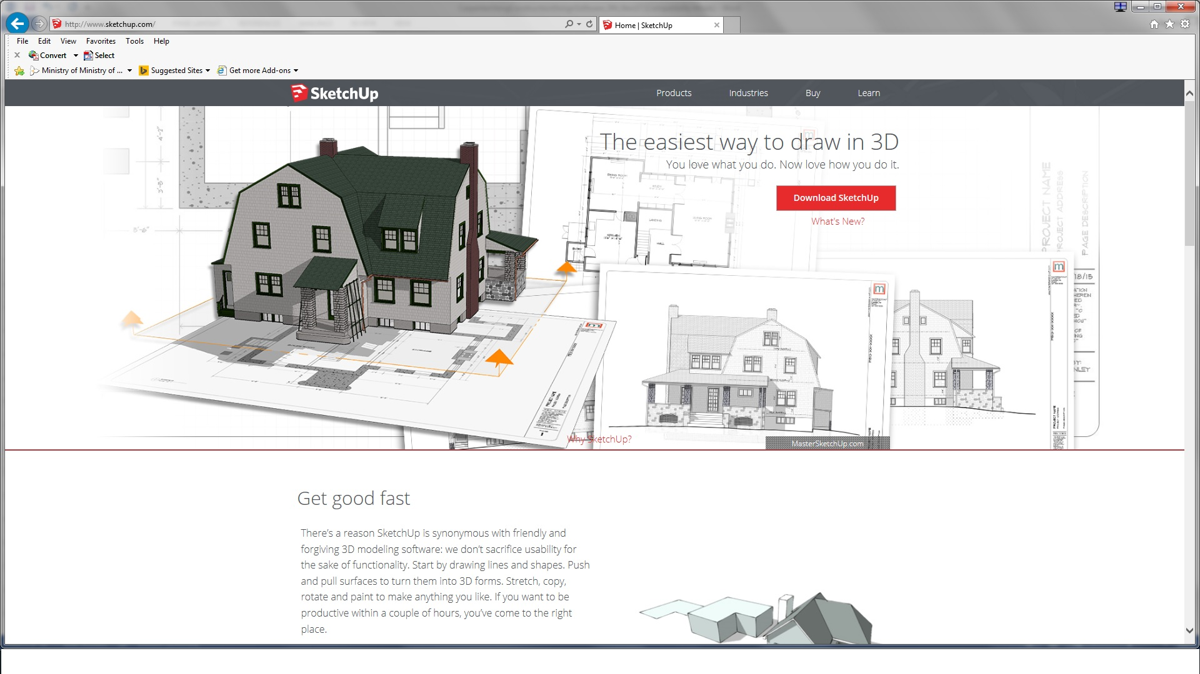

This is the screen shot of the SketchUp Learn page with the Part 1 video shown (November 17, 2014). This page may be accessed through the Learn link on the horizontal menu or by selecting the ‘getting started video’ link a little further down this page.
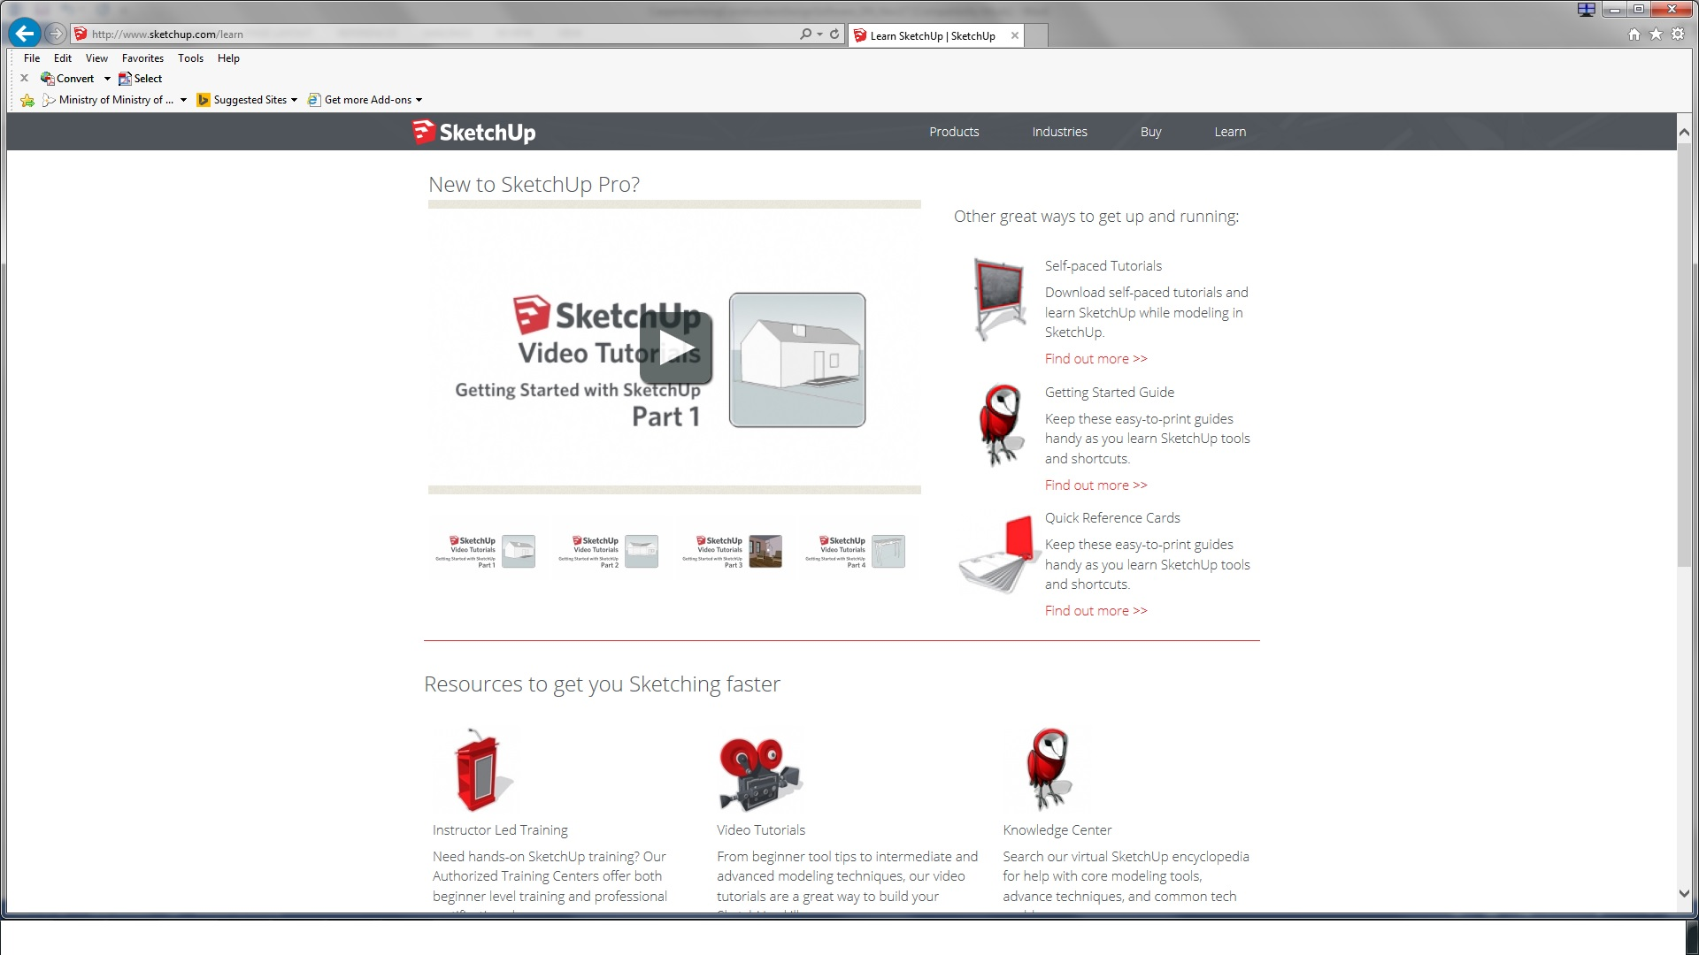
- Click and release your mouse
- Imperial (or feet and inches). The learner may also only say inches as that is all that is being indicated in the example.
- Push or pull any flat surface (they may also say makes the image 3D)
- The red dot indicates you are on the edge of a shape.
- Inference points
- The orbit, pan and zoom tools allow you to navigate in SketchUp.
- It will turn blue.

Task 1c: This is the screen shot of the SketchUp Learn page with the Part 3 video shown (November 17, 2014).
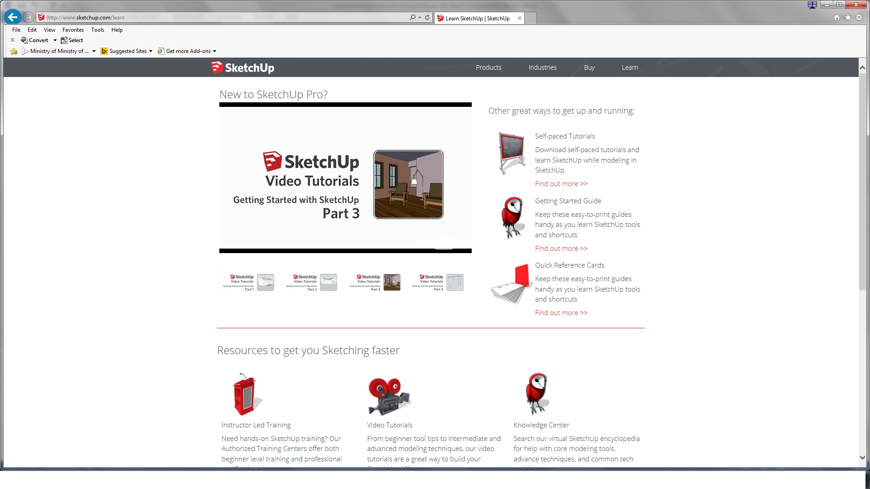
- The length of the wall with the 3 windows is 20’.
- The wall is 20’ long. Each window is 30” wide. Convert 30” to feet.
30/12 = 2.5
30” = 2.5’
The distance between the windows is 45”. Convert 45” to feet
45/12 = 3.75’
45” = 3.75’
Add the window widths and the space between them.
2.5’ + 2.5’ + 3.75’ = 8.75’
Subtract this total from 20’ to determine how much wall space is available.
20 – 8.75 = 11.25’

Since the windows will be centred on the wall, the distance from each window to the wall corner will be the same.
To determine the distance from the left corner of the wall to the left side of the left window, divide the remaining distance (11.25’) in half.
11.25/2 = 5.625’ (or 5’ 7 1/2”)
The left edge of the left window will be 5.625’ from the left edge of the wall.
OR
The learner may convert to inches:
20’ x 12 = 240” is the length of the wall
2 windows x 30” = 60”
60” + 45” = 105”
240” – 105” = 135”
135” ÷ 2 = 67.5”
The left edge of the left window will be 67.5” from the left edge of the wall.

Task Title: Carpenter Using Construction Design Software
Performance Descriptors |  | Needs Work | Completes task with support from practitioner | Completes task independently
A2.2 | - performs limited searches using one or two search criteria
 | - extracts information from tables and forms
 | - uses layout to locate information
 | - makes connections between parts of documents
 | - makes low-level inferences
A3 | - the tasks in this task group are not rated for complexity
C3.3 | - calculates using numbers expressed as whole numbers, fractions, decimals, percentages and integers
 | - manages unfamiliar elements (e.g. context, content) to complete tasks
 | - chooses and performs required operations; makes inferences to identify required operations
 | - selects appropriate steps to solutions from among options
 | - identifies a variety of ways to complete tasks
 | - interprets, represents and converts measures using whole numbers, decimals, percentages, ratios and fractions
 | - uses strategies to check accuracy (e.g. estimating, using a calculator, repeating a calculation, using the reverse operation)
D.2 | - selects and follows appropriate steps to complete tasks
 | - locates and recognizes functions and commands
 | - makes low-level inferences to interpret icons and text
 | - performs simple searches using keywords (e.g. internet, software help menu)

This task: was successfully completed___ needs to be tried again___

Learner Comments

____________________________ _________________________

Instructor (print) Learner Signature

