
OALCF Task Cover Sheet

Task Title: Using a Provincial Park map
Learner Name:

Date Started: Date Completed:

Successful Completion: Yes___ No___
Goal Path: Employment ✓ Apprenticeship___ Secondary School ✓ Post Secondary___ Independence ✓
Task Description:
Navigating a provincial park using a map.
Competency:  A: Find and Use Information | Task Group(s):  A1: Read continuous text  A2: Interpret documents
Level Indicators:
A1.1: Reads short texts to locate a single piece of information
A2.2: Interpret simple documents to locate and connect information
Performance Descriptors: see chart on last page
Materials Required:
- Pen and paper
- Caliper Lake park map and map legend

Learner Instructions:.

When people visit Provincial Parks, they will often use a map and its legend to find their way around the park. Use the attached map and its legend to answer the following questions about the Provincial Park map.

- Highlight the route you would take from the park Entrance to camp site #75 according to the camp map.

- On the park map, circle the nearest toilet to site #75.

- According to the map, is site # 75 close to a tap? ________________________________________

- Which campsites could you reserve if you wanted a site with electricity, but also near the hiking trail?

_________________________________________________________

- If you were using your own boat at this park, what place would you need to locate?

__________________________________________________________

- On the park map, circle the area where would you park your vehicle for an afternoon picnic.

- According to the park map, how many pay phones are there in the park?

__________________________________________________________

- Circle on the map where you should camp if you were camping with a large group of friends.

- On the park map, circle where you would go to have a shower.

- On the park map, circle where you would go to get wood for a campfire.

Map Icons Legend
Symbol | Meaning | Symbol | Meaning | Symbol | Meaning
 | Electrical Campsite |  | Non - Electrical Camping |  | Parking
 | Group Camping |  | Information |  | Visitor Center
 | Gatehouse |  | Park Office |  | Park Store
 | Garbage |  | Recycling |  | Trailer Dumping
 | Trailer Filling |  | Water Tap |  | Pit/Vault Toilet
 | Comfort Station |  | Comfort Station with Showers |  | Laundry Facilities
 | Radio Free |  | Wheel Chair Accessible |  | Boat Launch
 | Day Use Area |  | Picnic Shelter |  | Water/Canoe Route
 | Park Property |  | Private Property |  | Portage Routes
 | Beach |  | Amphitheater |  | Fishing / Cleaning Station
 | Campfire Circle |  | Swimming |  | Playground
 | Hiking |  | Canoeing |  | Canoe Launch
 | Canoe Rack |  | Horseshoes |  | Ball Diamond / Play Field
 | Pay Phone |  | Marsh |  | Volleyball / Basketball Court
 | Biking |  | Cemetery |  | Change Room
 | Church |  | Emergency Phone |  | Grocery
 | Firewood |  | First Aid |  | Picnic Area
 | Group Picnic Area |  | Horse Back Riding |  | Lookout
 | Organic Waste |  | Exercise Area |  | Pet Free
 | Portage |  | Warming Hut |  | Self Serve Fee Station
 | Walkin Campsite
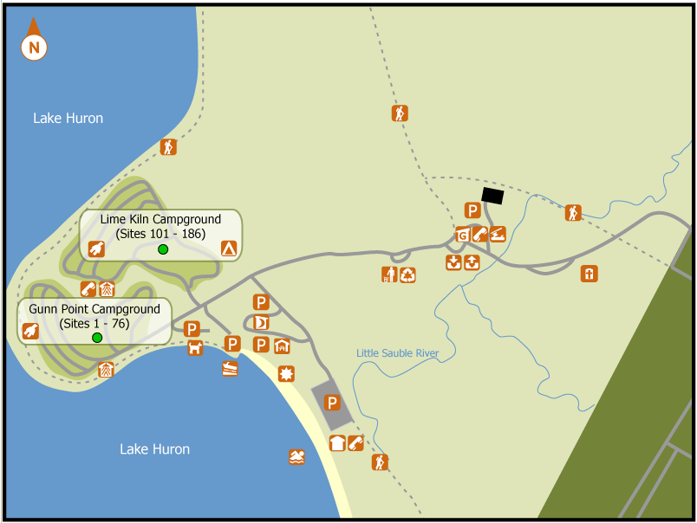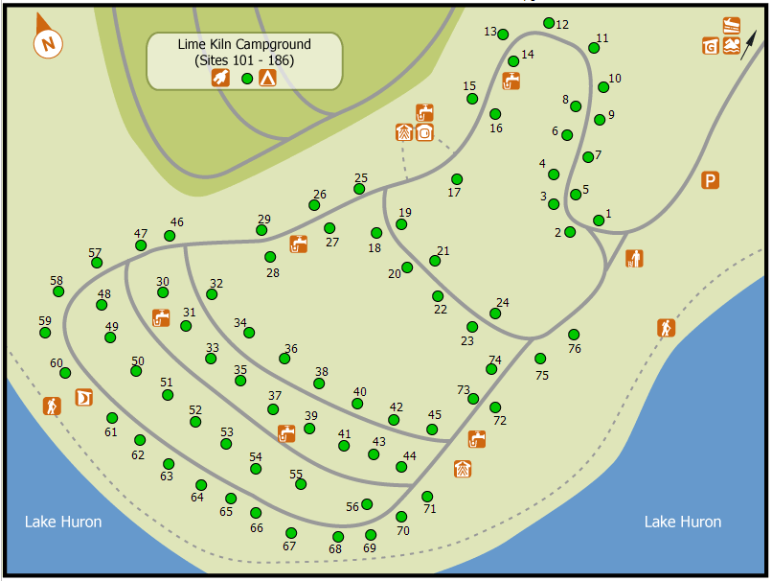

Task Title: Using a Provincial Park map
Performance Descriptors |  | Needs Work | Completes task with support from practitioner | Completes task independently
A1.1 | - reads short texts to locate a single piece of information
 | - decodes words and makes meaning of sentences in a single text
 | - follow simple, straightforward instructional texts
A2.2 | - performs limited searches using one or two search criteria
 | - locates information in simple graphs and maps
 | - uses layout to locate information
 | - makes connections between parts of documents
 | - makes low-level inferences

This task: was successfully completed___ needs to be tried again___

Learner Comments

____________________________ _________________________

Instructor (print) Learner Signature

