Task-based Activity Cover Sheet
Task Title: Verify Contact Information on a Simple Personal Information Form
Learner Name:

Date Started: Date Completed:

Successful Completion: Yes___ No___
Goal Path: Employment __ Apprenticeship __ Secondary School __ Post Secondary __ Independence ✓
Task Description:
Learner will find and correct personal information errors on a Canadian T1 General Income Tax and Benefit Return
Competency:  A: Find and Use Information  B: Communicate Ideas and Information | Task Group(s):  A2 Interpret Documents  B3 Complete and Create Documents
Level Indicators:
A2.1: Interpret very simple documents to locate specific details
B3.1a: Make straightforward entries to complete very simple documents
Performance Descriptors: see chart on last page or click here
Links to skill building activities: see the last page or click here
Materials Required:
- Print the T1 General form below (preferably in colour) and fill in the learner’s name and complete address ONLY. Intentionally include errors in:
      - The learner’s middle initial
      - The street number
- Use pencil, so the form can be corrected more easily and neatly. The Canada Revenue agency website is here: http://www.cra-arc.gc.ca
ESKARGO:
Building Readiness for A2.1 Tasks
- Reads sight words commonly used in simple documents (e.g., days of the week, months of the year, name, address, telephone number, etc.)

Skills and Knowledge Required for Successful Task Performance

Reading Strategies – Decoding and Comprehension Enhancement
- Uses knowledge of vocabulary and sight words related to specific signs, labels, lists and
- simple forms to understand text
- Uses phonics and knowledge of word parts to decode words
- Uses knowledge of basic abbreviations to gather meaning from text
Forms and Conventions – Find Information/Research/Understand Types of Texts
- Scans to locate a single piece of information or specific details
Attitudes:
Practitioner,
We encourage you to talk with the learner about attitudes required to complete this task set. The context of the task has to be considered when identifying attitudes.
With your learner, please check one of the following:
□ Attitude is not important □ Attitude is somewhat important □ Attitude is very important

Task Title: Verify Contact Information on a Simple Personal Information Form
Federal Income Tax forms and other official forms will sometimes come with your personal information already filled in. It is important to make sure this information is correct. Look at the “Income Tax and Benefit Return” form that was completed for you.
Learner Information and Tasks:
Task 1: Check and correct any errors in your name.

Task 2: Check and correct any errors in your address.

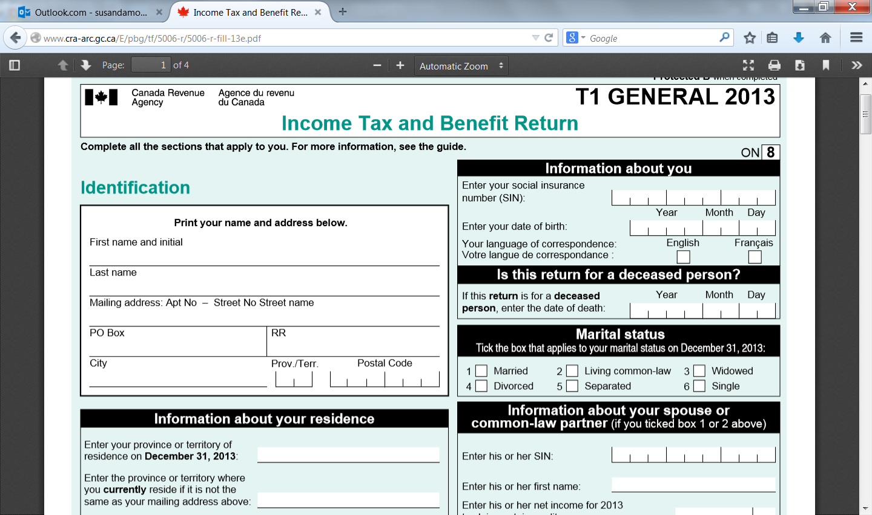

Task Title: Verify Contact Information on a Simple Personal Information Form

Answer Key
Tasks 1-2: Answers will vary, but they will need to correct the middle initial mistake and the street address number

Task Title: Verify Contact Information on a Simple Personal Information Form
Performance Descriptors |  | Needs Work | Completes task with support from practitioner | Completes task independently
A2.1 | - scans to locate specific details
 | - interprets brief text and common symbols
 | - locates specific details in simple documents, such as labels and signs
B3.1a | - makes a direct match between what is requested and what is entered
 | - makes entries using familiar vocabulary

This task: was successfully completed___ needs to be tried again___

Learner Comments

____________________________ _________________________

Instructor (print) Learner Signature

Skill Building Activities
Links to online resources:
- BBC Skillswise – “Filling in a Form” – http://www.bbc.co.uk/skillswise/topic/filling-out-a-form - learn about the varying purposes of forms, how and where to enter information into a form, and the language and format of forms; by learning to fill in forms, the learner can also develop skills for scanning for specific details when reading a form
- BBC Skillswise – “Skimming and Scanning” – http://www.bbc.co.uk/skillswise/topic/skimming-and-scanning - learn principles of scanning documents, such as using clue words, headings and titles to direct the eye, and knowing in advance what type of information is being sought
- Literacytools – “Filling in Forms” – http://www.literacytools.ie/pages/actions/viewPdfFile.cfm?pId=184 – tips for filling in forms; more about format and language; practise entering personal information into a variety of forms
- Skill Plan’s, “Measure Up” - http://www.skillplan.ca/measure-up , (select “English”, “Choice of Activities”, “Practice”, “Reading”, and “Labels or Forms with at least one paragraph of text”) – tasks to practise locating specific details in labels and forms
- LaRue Literacy Exercises – “Filling Out a Form” - http://www.mcedservices.com/litex/litex.htm - (Scroll down to “Printable Literacy Learning Activities”, then download the Introduction and Lessons 3.1-3.3 for “Filling Out a Form”) – example of how to fill in personal information into a form; locate details in form, then answer questions; using information provided, fill out a form

LearningHUB Courses Available:

- Live Classes (SABA) - “Filling In Forms”& “Reading Comprehension”
- Essential Skills, Independent Study (Assigned by practitioner after assessment)
  - Document Use Level 1, Assignment 1: Reading Basic Forms
  - Document Use Level 2, Assignment 2: Locating the Details, Proceeding through Forms

*To access LearningHUB courses, learners must register for the LearningHUB e-Channel program by completing the registration form on their website and completing the course selection (page 2 of the registration form): https://www.learninghub.ca/get_registered.aspx
*To Access LearningHUB Course Catalogue:
http://www.learninghub.ca/Files/PDF-files/HUBcoursecatalogue,%20December%2023,%202014%20revision.pdf

