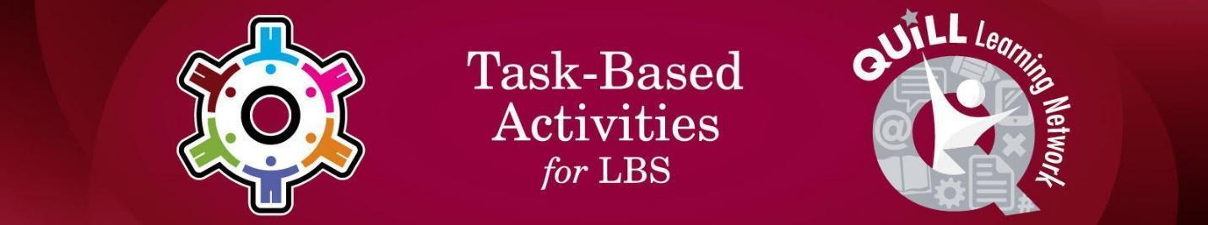

Task Title: Watch a Safety Video to Learn About the Potential Hazards in a Workplace

# OALCF Cover Sheet – Practitioner Copy

**Learner Name:___________________________________________**

**Date Started:____________________________________________**

**Date Completed: _________________________________________**

|  |  |  |
| --- | --- | --- |
| **Goal Path:** | Employment | Apprenticeship |
| Secondary School | Post Secondary | Independence |

**Successful Completion:**  Yes No

**Task Description:**

The learner will watch and respond to an employer safety video.

**Main Competency/Task Group/Level Indicator:**

* Find and Use Information/Extract information from films, broadcasts and presentation/A3

**Materials Required:**

* Pen/pencil and paper
* Computer or digital device

# Learner Information

Employees are often asked to watch safety videos to learn about hazards at the workplace.

Watch the video *Safety is Personal: An Employer’s Story*:

<https://www.youtube.com/watch?v=x9WthTBEKsw>

# Work Sheet

**Task 1: Who is the intended audience for this safety video?**

Answer:

**______________________________________________________**

**Task 2: What is the main idea of the safety video you watched?**

Answer:

**______________________________________________________**

**Task 3: What information did the safety video present to support the title of the video “Safety is Personal”?**

Answer:

**______________________________________________________**

**Task 4: Briefly describe the presentation technique used in the video you watched.**

Answer:

**______________________________________________________**

**Task 5: What is the main “lesson” Mike Honeyman learned from his employee’s accident?**

Answer:

**______________________________________________________**

# Answers

**Task 1: Who is the intended audience for this safety video?**

Answer: The intended audience is mainly employers/managers/business

owners.

**Task 2: What is the main idea of the safety video you watched?**

Answer: Employers learn hard lessons when an employee is injured on the

job; you can’t just have a book on safety you have to make sure that

employees know the importance of safety and what the book contains.

**Task 3: What information did the safety video present to support the title of the video “Safety is Personal”?**

Answer: Answers will vary but may include

* safety investigations are a difficult process and can be very stressful
* a company can lose everything when an employee is injured
* when an employee is injured people start looking at the company differently and assume that the owners don’t care about safety

**Task 4: Briefly describe the presentation technique used in the video you watched.**

Answer: Answers will vary but should reflect that the video uses a narrative (story-telling) presentation technique.

**Task 5: What is the main “lesson” Mike Honeyman learned from his employee’s accident?**

Answer: Answers will vary but will reflect the following message: It doesn’t matter what you have written down in the book – the safety message has to translate into something meaningful to the people you work with. You must let people know you really want them to be safe and to do what they need to do to ensure that everyone is safe on the job.

# Performance Descriptors

| Levels | Performance Descriptors | Needs Work | Completes task with support from practitioner | Completes task independently |
| --- | --- | --- | --- | --- |
| A3 | Extract info from films, broadcasts and presentations |  |  |  |



This task: Was successfully completed Needs to be tried again

Learner Comments:

Instructor (print): Learner (print):

**__________________ _________________**

Skill Building Activities

BBC Skillwise – “Listening for Specifics”. Learn tips for identifying key details when listening in a variety of situations. Play games to practice the skill.

<https://www.bbc.co.uk/teach/skillswise/articles/zrfqrj6>

Skills You Need – “Note Taking”. Learn how note-taking helps with comprehension of oral communication in personal, employment and academic settings by providing a means to summarize and retain key points.

<https://www.skillsyouneed.com/write/notes-verbal.html>